User’s Guide

For The

OahuMPO Planning Model

In TransCAD 6.0

Submitted To:
 | OahuMPO  707 Richards Street, Suite 200  Honolulu, Hawaii 96813-4623

Submitted By:
 | Parsons Brinkerhoff  American Savings Bank Tower, Suite 2400  1001 Bishop Street  Honolulu, Hawaii 96813

June 2013

(This page intentionally left blank)

Table of Contents
List of Tables 4
List of Figures 5
1. Introduction 7
1.1 OMPO6.0 Overview 8
2. Software 13
• TransCAD 13
• Java 13
• GNU tools 13
• Microsoft Excel (not required but helpful) 13
3. Directory Structure 14
4. Basic Inputs 24
4.1 Highway Network 24
4.1.1 How to code a new road 30
4.1.2 Modifying an existing road 31
4.2 Transit Network 31
4.2.1 Adding a new transit route 35
4.2.2 Modifying an existing transit route 35
4.3 Traffic Analysis Zones 36
4.4 Urbansim Data 41
5. Graphical User Interface (GUI) 47
5.1 GUI Components 47
5.2 Launching the GUI 52
5.3 GUI Navigation 54
5.4 Creating a Scenario 56
5.4 Running a Scenario 57
5.4.1 Prepare Network 58
5.4.2 Create Highway Skims 64
5.4.3 Create Transit Skims 65
5.4.4. Special Market Models 70
5.4.5 Tour-Based Models 79
5.4.6 Time of Day 87
5.4.7 Highway Assignment 93
5.4.8 Transit Assignment 97
6. Environmental Justice Summaries 102

List of Tables

Table 1: List of Control Files 18
Table 2: List of UEC Files 18
Table 3: List of Program Files 20
Table 4: Network Inputs 20
Table 5: GISD-K Files 20
Table 6: List of Report/Log Files 21
Table 7: List of Other Inputs 22
Table 8: Highway Line Layer Attributes 26
Table 9: Transit Network Attribute Data 32
Table 10: TAZ Spreadsheet Data (.\generic\inputs\taz\YYYY\yYYYYtazdata.xls) 37
Table 11: TAZ Layer Attribute Data 38
Table 12. Urbansim Synthesized Households.csv file 41
Table 13. Urbansim Synthesized Persons.csv file 44
Table 14: Options for running the OahuMPO models 57
Table 15: Facility Types 59
Table 16: Area-Type Definitions Based on Population and Employment Densities* 60
Table 17: Free-Flow Speed Look-up Table (\generic\inputs\other\ FSPED.bin) 60
Table 18: Congested Speed Look-up table (\generic\inputs\other\ CSPED.bin) 61
Table 19: Capacity Look-up Table (\generic\inputs\other\ ACAPA.bin) 61
Table 20: Alpha Parameters in the Volume Delay Function 62
Table 21: Transit Peak Travel Time Factors (\generic\inputs\other\ TRANPKTIMEFAC.bin) 62
Table 22: Transit Off-Peak Travel Time Factors 63
Table 23: Link and Distance Thresholds Used in Transit Access Connections 64
Table 24: Highway and Transit Skim Tables 67
Table 25: Transit Mode Table (\generic\inputs\other\modes.bin) 68
Table 26: Global Transit Pathfinder Parameters 69
Table 27: Summary of Truck Trips by Purpose 74
Table 28: Tours.csv Data Dictionary 80
Table 29: Trips.csv Data Dictionary 82
Table 30: VisitorTours.csv Data Dictionary 83
Table 31: VisitorTrips.csv Data Dictionary 85
Table 32: Key Destination Zones 102
Table 33: Output Files for Environmental Justice Summaries 102
Table 34: Output Matrix for Environmental Justice Summary 103

List of Figures

Figure 1: OahuMPO Modeling System 12
Figure 2: Generic directory structure 14
Figure 3: Scenario directory structure 15
Figure 4: Conflated Highway Network 25
Figure 5: Route System Info (Dynamically shows up on selecting a transit route with info tool) 32
Figure 6: 2005 Oahu Transit Network 34
Figure 7: TAZ Layer 40
Figure 8: GUI For OahuMPO Planning Model 49
Figure 9: Scenario Manager Dialog Box 50
Figure 10: Inputs Dialog Box 51
Figure 11: GUI Navigation 55
Figure 12: Truck Trip Generation Control File (TRKGEN5.CTL) 71
Figure 13: Airport Trip Generation Control File (AIRGEN5.CTL) 72
Figure 14: Trip Generation Report File for Truck Trips 73
Figure 15: Trip Distribution Report File 77
Figure 16: Time of Day Report for Truck Trips and Visitor Trips 88
Figure 17: Time of Day Report for Air Passenger Trips 89
Figure 18: Vehicle Trips by Time Period and Classification 89
Figure 19: Transit Trips by Time Period and Mode 91
Figure 20: Highway Assignment Report File 94
Figure 21: Highway Assignment Report File-2 94
Figure 22: Highway Assignment Report File-3 95
Figure 23: Transit Assignment Report File 100

Introduction

This user’s guide is designed to familiarize the user with the TransCAD version of the OahuMPO regional travel demand forecasting model, hereafter referred to as ‘OMPO6.0’. This new version of the OahuMPO travel demand model is similar to the OMPO5.0 TransCAD model with the exception that the demand models are now tour-based models for both residents and visitors and implemented in JAVA. Additionally, the model was implemented in TransCAD version 6.0, which offers a similar user experience as version 5.0 but with additional features such as multi-threaded assignments. The user can familiarize themselves with the tour-based models in the report Tour Based Travel Model Estimation: for Oahu Metropolitan Planning Organization and Deliverable HITS R1.9 Oahu Visitor Model. The model is run on the TransCAD 6.0 64-bit system and the 2012 model runs in approximately 3 hours on a 64-bit 3.33 GHz dual-processor Intel Xeon machine with 48 GB of RAM.

This User’s Guide covers the following topics
- The software used to run the OMPO6.0 model.
- The directory structure used to set up and run the OMPO6.0 model system
- The inputs used by the OMPO6.0 model system and the outputs produced by the OMPO6.0 model system
- The graphical user interface (GUI) for the OMPO6.0 model, as shown in Figure 1.

The remaining part of this section gives an overview of the OMPO6.0 model. The directory structure used for organizing the generic inputs to the model system and scenario-specific model runs is described in Section 2. Section 3 describes the inputs used by the models, including networks and network coding. The model GUI and each model component is described in Section 4.

1.1 OMPO6.0 Overview

The OMPO6.0 model is comprised of a sequence of steps that model all travel for the island of Oahu. The resident models are stratified based on seven purposes (Work, University, School, Escorting, Maintenance, Discretionary and At-Work), and the model system includes visitor travel, airport travel, and truck (commercial vehicle) travel components.

Each model step is briefly described below and the full model set developed for OahuMPO is depicted in Figure 1.
- There are two Special Market Models that are applied before the residential tour based models, the air-passenger model, and the truck (commercial vehicle) model. These two models are implemented in FORTRAN and GISDK scripts.
- The following 7 components describe the Residential tour based models:
- Long-term models include the preliminary auto ownership model, which calculates the number of cars owned by each household in the synthetic population, and the mandatory location choice model, which predicts the work TAZ for each worker and the school TAZ for each student.
- Medium-term models include the final auto ownership model and the free parking eligibility model which predicts whether each worker must pay for parking or has their parking reimbursed by their employer.
- The Daily and Tour Level models include the following components:
  - The Tour Frequency model predicts the number of mandatory (work, university, and school), non-mandatory (escorting, maintenance, discretionary), and at-work sub-tours for each person.
  - The Tour Destination model predicts the location of where the traveler is going based on mode choice logsums, distance terms, zonal employment and household and person attributes as explanatory variables.
  - The Tour Time-of-Day model predicts the departure and arrival time periods for each tour in half-hour increments.
  - The Tour Mode Choice model determines the “main tour mode” used to get from the origin to the primary destination and back. The tour-based modeling approach requires a certain reconsideration of the conventional mode choice structure. Instead of a single mode choice model pertinent to a four-step structure, there are two different levels where the mode choice decision is modeled:
    - The tour mode level (upper-level choice),
    - The trip mode level (lower-level choice conditional upon the upper-level choice).
    - The alternative modes include (auto, transit, and non-motorized travel), occupancies (1, 2, and 3+ per vehicle), transit access-modes (walk, park/ride-formal, park/ride-informal, and kiss/ride), transit paths (local, express, and fixed-guideway), walking, bicycling, and school bus (only for School tours/trips). If the toll model option is selected, the model also splits the auto trips by occupancy into toll/non-toll choice, for a total of 16 alternatives. The model considers a large number of characteristics of the tour/trip, the traveler, and the competing travel options to estimate the shares attracted to each option.
- The stop level models include the following components:
  - A Stop Frequency model which predicts the number of intermediate stops on each tour
  - A Stop Purpose model which predicts the purpose of each stop.
  - A Stop Location choice model which predicts the location of each stop
  - A Stop Departure Time choice model which predicts the stop departure time in half-hour windows.
- Trip-level models consist of the following components:
  - The Trip Mode Choice model also referred to as the trip mode switching because it predicts the mode of each trip on each tour, which is conditioned by the chosen tour mode. The main mode is chosen at the tour level but this model predicts the mode for each individual trip on the tour.
  - Trips are summed up into the 5 time periods (early AM (3-6AM), AM peak period (6-9AM), midday (9-3PM), PM peak period (3-7PM), and evening periods (7PM-3AM) for Assignment to the highway and transit networks. This is done in the time-of-day factoring GISDK script, which also adds resident trips, visitor trips, truck trips, and airport trips.
- The Visitor tour based models is similar to the residential models except the tour enumeration step described below. The tour destination, tour time of day, tour mode choice, stop level models, and trip mode choice are similar to the residential models.
- The Tour Enumeration step generates the number of visitor parties by visitor segment (personal or business) and number of visitor tours by segment, party size and auto availability.
- The Highway Assignment model assigns the O-D vehicle trip table to the highway network and estimates the vehicular flow in the highway network. This assignment is done separately for early AM (3-6AM), AM-peak period (6-9AM), midday (9AM-3PM), PM-peak period (3-7PM), and evening period (7PM-3AM). The method of successive averages is used to compute averaged volumes for each iteration of the model system, and convergence is based on a comparison of peak period travel time matrices (the model reaches convergence if the percent root mean square error is less than 5%)
- The Feedback Loop measures the closeness of the current iteration assignment results with that of the previous iteration. If assignment results differ significantly between the current iteration and the previous iteration, the model is run again. However, if the assignment results do not differ significantly between the current iteration and the previous iteration, the model is flagged as converged and highway assignment is run for other time periods of the day, followed by transit assignment.
- The Transit Assignment model assigns the O-D person trip table to the transit network and estimates the boarding and alighting by transit route and stop.
- The Land Use Model can be run in order to generate the land use data. However, it should be noted that it is not mandatory to run the land use model in order to run the travel model.

Figure 1: OahuMPO Modeling System
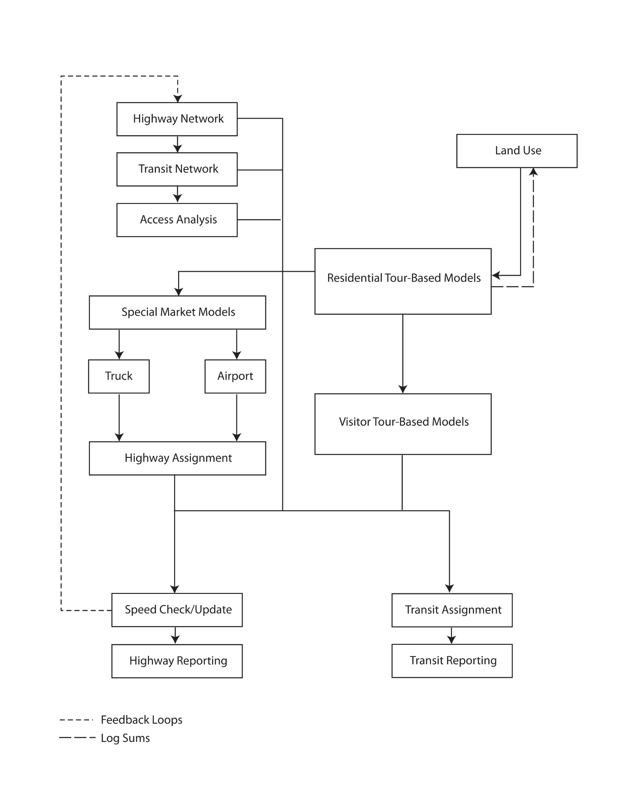

Software
The following software is required to execute the OMPO6.0 model.

TransCAD
The travel model currently uses TransCAD Version 6.0 r2 Build 9030 64-bit software. The TransCAD software is used to build skims, manipulate networks, manipulate matrices, perform assignments, and run the aggregate special market models. The Java software, as discussed below, needs to access matrix data in TransCAD format. In order to do this, the TransCAD matrix dll and Java matrix package is used.

Java
Oahu MPO’s residential and visitor travel model utilizes the open- source Java Common Modeling Framework (CMF) software developed by Parsons Brinckerhoff. The 64-bit Java Runtime Environment (version 1.7 or later) must be installed on the computer. The 64-bit version of the software allows the software to take advantage of larger memory addresses and read TransCAD matrices directly using the 64-bit TransCAD dongle.

GNU tools
The travel model utilizes a tool provided by the GNU free software foundation to redirect, or “pipe”, output from a DOS process (specifically Java) to a text file. This is useful in case the java process terminates in an error, as the text file can be opened to determine what the error might have been. The GNU Win32 tools can be downloaded from sourceforge.net (http://gnuwin32.sourceforge.net/).

Microsoft Excel (not required but helpful)
The discrete choice models are specified via spreadsheets, referred to as Utility Expression Calculators or UECs. These files are Excel-based. See Table 2 for a more detailed explanation on these Excel files. It is helpful to have Excel installed so that the spreadsheets can be opened, though it is not essential for running the model system.

Directory Structure

There are two types of folders used in the OahuMPO model conversion project. They are:
- A single ’generic’ folder, which contains all of the model inputs, including the Master highway and transit networks, TAZ files, and other required data.
- One or more ’scenario’ folders, which is the working directory for a given scenario and includes all of the inputs to the particular scenario and outputs created after a scenario is run.

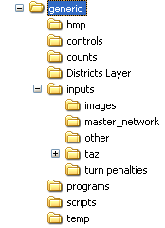
Figure 2: Generic directory structure

The generic directory structure is shown in Figure 2. The sub-folders listed under generic folder are described below:
- bmp: Contains some of the images used for display in GUI. These should be copied into the bmp subdirectory of the TransCAD install directory.
- Controls: Contains control files and for each model step. Each control file contains inputs, parameters, and outputs for its corresponding model. This folder also contains the UEC files needed for the residential and visitor tour based models. The oahu_tbm.properties file specifies the location of all the inputs, outputs, UEC files, and other tokens that need to be set. It also specifies which model components to run.
- Counts: Contains the traffic count data, provided by the Hawaii DOT, for year 2005.
- Districts layer: Contains the district layer.
- Inputs: Contains the master TAZ layer, master line layer, turn penalties, and other inputs.
  - Master_network: Contains the master line layer and the master route system databases, as listed in Table 4
  - Other: Contains all the look-up tables.
  - TAZ: Contains the zonal data for each scenario year, e.g. the 2010 zonal data is stored in “2010” folder.
  - Turn_penalties: Contains turn penalties from one link to another adjacent link by time of day.
- Programs: Contains the main programs for running the model steps. It also has the CTRampEnv.bat file that sets the location of the java runtime environment, TransCAD, and the gnu win32 tools used for the model run. The runOMPOTbm.cmd contains a list of MS-DOS instructions that control model flow. And the ompo.jar file holds all the compiled code needed to run the tour-based models.
- Scripts: Contains all the TransCAD GISDK scripts used to run procedures in the OMPO6.0 model.

The scenario folders contain all the relevant files used to run the model for a specific year. It should be noted that these scenario folders can be anywhere and can be named anything. The files and folders in a scenario specific folder are organized in a particular directory structure as shown in Figure 3.
Figure 3: Scenario directory structure
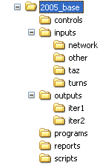

The folder “2005_base” is a scenario folder. Although the scenario folder can be named anything, it is advisable to choose a name that represents both the study year and the scenario. For example, the name “2005_base” is chosen such that it represents the study year “2005” and the scenario, which is “base scenario”. The sub-folders listed under scenario folder are described below:

- Controls: Contains control files and UECs for each model step. Each control file contains inputs, parameters, and outputs for its corresponding model. The UECs define the inputs used for the model and the logit model coefficients and constants. The oahu_tbm.properties file specifies the location of all the inputs, outputs, UEC files, and other tokens that need to be set. It also specifies which model components to run. The list of control files and UECs used for OahuMPO model is listed in Table 1 and Table 2, respectively.
- Inputs: Contains the scenario TAZ layer, scenario line layer, turn penalties, and other inputs.
  - Network: Contains the scenario line layer and the scenario route layer, the file names of the databases are listed in Table 4.
  - Other: Contains all the look-up tables. The list of other inputs used in OahuMPO model is listed in Table 7.
  - TAZ: Contains the scenario zonal data (tazdata.csv and y<year>tazdata.xls), and the households.csv/persons.csv files from Urbansim.
  - Turns: Contains turn penalties from one link to another adjacent link by time of day.
- Outputs: Contains the processed results for all iterations.
  - Iter1: Contains the outputs at each model step for iteration 1.
  - Iter2: Contains the outputs at each model step for iteration 2.
- Programs: Contains the main programs for running the model steps, the CTRAMPEnv.bat, the RunOMPOTBM.cmd, and the ompo.jar files. The list of these programs and files used for OahuMPO model is listed in Table 3.
- Reports: Contains a report for each step in the model. The list of report files generated while running the OahuMPO model is listed in Table 6.
- Scripts: Contains a backup of all the scripts used to run procedures in this scenario. Note that the scripts are typically not actually run from this directory, but instead the scripts are typically compiled into a UI database and run from the generic\scripts directory. The list of scripts used for OahuMPO model is listed in Table 5.

Table 1: List of Control Files
Model Step | Control File | Description (Control file for)
Trip Generation | AIRGEN5.CTL | Trip generation for airport access trips
Trip Generation | TRKGEN5.CTL | Trip generation for truck trips

Table 2: List of UEC Files
UEC File | Description (UEC file for)
Accessibilities.xls | Origin-based accessibility UEC
MandatoryAlts.csv | Mandatory tour frequency alternatives (Number of work, university, school tours)
NonMandatoryAlts.csv | Non-mandatory tour frequency alternatives (number of escort, maintenance, and discretionary tours)
ResidentAtWorkSubTourFrequency.xls | Resident At-Work Sub Tour Frequency UEC
ResidentAutoOwnership.xls | Resident Auto Ownership Model UEC
ResidentInboundStopDurationDistributions.csv | Resident Inbound Stop Duration Distributions (by 15 minute interval period and stop number)
ResidentMandatoryTourFrequency.xls | Resident Mandatory Tour Frequency UEC
ResidentNonMandatoryTourFrequency.xls | Resident Non-mandatory Tour Frequency UEC
ResidentOutboundStopDurationDistributions.csv | Resident Outbound Stop Duration Distributions (by 15 minute interval period and stop number)
ResidentStopFrequencyDistributions.csv | Resident Stop Frequency Distributions by tour purpose, duration, and number of inbound/outbound stops
ResidentStopFrequencyDistributions_FTWorkers.csv | Full Time Workers Stop Frequency distributions
ResidentStopLocationChoice.xls | Resident Stop Location UEC
ResidentStopLocationChoiceAlternatives.csv | Resident Stop Location Choice Alternatives (15)
ResidentStopLocationChoiceSOA.xls | Resident Stop Location Choice Sample of Alternatives UEC
ResidentStopPurposeDistributions.csv | Resident Stop Purpose Distributions by tour purpose, inbound stop, stop number, multiple stops on tour indicator
ResidentTourDestinationChoice.xls | Resident Tour Destination Choice UEC
ResidentTourDestinationChoiceAlternatives.csv | Resident Tour Destination Choice Alternatives (30)
ResidentTourDestinationChoiceSOA.xls | Resident Tour Destination Choice Sample of Alternatives UEC including size terms
ResidentTourDestinationChoiceSOAAlternatives.csv | Resident Tour Destination Choice Sample of Alternatives file (764)
ResidentTourModeChoice.xls | Resident Tour Mode Choice UEC
ResidentTourTimeOfDayDistributions.csv | Resident Tour Time of Day Distributions by tour purpose and 30 minute entry and return periods
ResidentTripModeChoice.xls | Resident Trip Mode Choice UEC
Skims.xls | Skims UEC
VisitorAutoAvailableFrequencyDistribution.csv | Visitor Auto Availability by tour purpose frequency distribution
VisitorInboundStopDurationDistributions.csv | Visitor Inbound Stop Duration Distributions (by number of 30 minute intervals offset from tour arrival time period, periods remaining, and stop number)
VisitorIncomeFrequencyDistribution.csv | Visitor Income by Segment (personal/business) frequency distribution
VisitorOutboundStopDurationDistributions.csv | Visitor Outbound Stop Duration Distributions (by number of 30 minute intervals offset from tour departure time period, periods remaining, and stop number)
VisitorPartySizeFrequencyDistribution.csv | Visitor Party Size by tour purpose frequency distribution
VisitorStopFrequencyDistributions.csv | Visitor Stop Frequency Distributions by tour purpose, duration, and number of inbound/outbound stops
VisitorStopLocationChoice.xls | Visitor Stop Location UEC
VisitorStopLocationChoiceSOA.xls | Visitor Stop Location Choice Sample of Alternatives UEC
VisitorStopPurposeFrequencyDistributions.csv | Visitor Stop Purpose Distributions by tour purpose, inbound stop, stop number, multiple stops on tour indicator
VisitorTourDestinationChoice.xls | Visitor Tour Destination Choice UEC
VisitorTourDestinationChoiceSOA.xls | Visitor Tour Destination Choice Sample of Alternatives UEC
VisitorTourFrequencyDistributionBusiness.csv | Visitor Tour Frequency Distribution for Business segment
VisitorTourFrequencyDistributionPersonal.csv | Visitor Tour Frequency Distribution for Personal segment
VisitorTourModeChoice.xls | Visitor Tour Mode Choice UEC
VisitorTourTimeOfDayDistributions.csv | Visitor Tour Time of Day Distributions by tour purpose and 30 minute departure and arrival periods
VisitorTripModeChoice.xls | Visitor Trip Mode Choice UEC

Table 3: List of Program Files
Program | Description
CTRampEnv.bat | Sets the location of java, TransCAD, and the GNU win32 tools. Please make sure the paths for these programs are set correctly. The location of java, TransCAD, and the GNU tools’ installation are all custom to the machine.
HNL5AIRP.exe | Air Passenger program
HNL5SPGN.exe | Special generation program
Ompo.jar | Compiled code needed to run the tour-based models
runOmpoTbm.cmd | List of MS-DOS instructions that control model flow

Table 4: Network Inputs
File name | Description
Oahu Network 102907.dbd | Master line layer, this data base file contains projects from all the planning horizon years including the base year.
Oahu Route System 102907S.dbd | Stop layer for the master route system.
Oahu Route System 102907.rts | Master route system, this route system file contains transit projects from all the planning horizon years including the base year.

Table 5: GISD-K Files
Resource file | Description
OMPOGUI.rsc | Opens up the graphical user interface and connects to the main macro.
OMPO6.rsc | Main macro used to run the entire model.
tazmanager.rsc | Create the TAZ layer for a given scenario year.
NetworkManager.rsc | Create the highway and transit line layer for a given scenario year.
UpdateLineLayer.rsc | Update the line layer with lookup table fields.
CreateHighwayNetwork.rsc | Create the highway network for a given scenario year.
TransitAccessLinks.rsc | Create transit access links in the scenario line layer.
HighwaySkim.rsc | TransCAD Macro used to generate highway skims.
TransitSkim.rsc | TransCAD Macro used to generate transit skims.
CalculateAutoImportance.rsc | Calculate the auto importance matrix which is used for the auto ownership model.
TODFactor.rsc | TransCAD Macro used to factor trip tables.
highwayAssign.rsc | This macro assigns highway trip tables to highway networks.
TransitAssignment.rsc | This macro assigns transit trip tables to transit networks.
CalculateEJ.rsc | This macro will perform environmental justice calculations.
tripdist.rsc | This macro runs a gravity model for commercial vehicle trip distribution.
convertFFAtoCSV.rsc | Converts fixed-format ASCII to comma separated value format.
ConvertMatricesToBinary.rsc | Converts matrix files to bin format.
ConvertMatricesToCSV.rsc | Convert matrix files to comma separated value format.
ConvertBinaryToMtx.rsc | Converts bin files to matrix file.
CopyFiles.rsc | Copies all files from one directory to another.
CloseAll.rsc | A utility macro that will close all open map windows.
RecodeValues.rsc | Recodes null values in line layer to 0.
TripDistReport.rsc | This macro performs trip length frequency distributions and district summaries on trip tables output from trip distribution.
CollapseMatrices.rsc | This macro collapses trip tables in multiple files according to an array.
CheckConvergence.rsc | Compares two matrices and performs and returns RMSE.
AppendAssign.rsc | Append highway assignment results from AM 2 Hour, AM 4 Hour, Off-peak, and PM 4 Hour to line layer.
Note: Italics refer to utility macros.

Table 6: List of Report/Log Files
Report File | Description (Report file for)
AIRGEN5.RPT | Trip generation for airport access trips
AIRP5RES.RPT | Trip Mode choice for airport access by residents
AIRP5TOUR.RPT | Trip Mode choice for airport access trips by visitors on tours
AIRP5VIS.RPT | Trip Mode choice for airport access by visitors
AssignmentSummary.rpt | Highway assignment summary
Hnl5TRKG.RPT | Trip generation for truck trips
Event.log | Main log file for Tour Based models
event-residentModel.log | Resident model log file
event-visitorModel.log | Visitor model log file
ResidentModelRunnerScreen_<iteration>.log | Resident model screen capture for each iteration
ResidentTripTablesScreen_<iteration>.log | Creation of Resident model trip tables screen capture for each iteration
ScreenlineLinks.rpt | Screenline links volumes and VOC by time of day
ScreenlineSummary.rpt | Screenline Summary report
SpeedData.csv | VMT by facility type, area type and speed group
unconn_taz.log | List of unconnected TAZs to transit
VisitorModelRunnerScreen_<iteration>.log | Visitor model screen capture for each iteration
VisitorTripTables_<iteration>.log | Creation of Visitor model trip tables screen capture for each iteration

Table 7: List of Other Inputs
Look-up table | Description
26equiv.dat | 764 TAZ to 26 District lookup table
764to23.eqv | 764 TAZ to 23 District lookup
ACAPA.bin | Per lane per hour capacity by facility type and area type
Census2000ToModelOccupationCrosswalk.csv | Census 2000 and occupation lookup
Census2009ToModelOccupationCrosswalk.csv | Census 2009 and occupation lookup
Conical.bin | Volume delay function parameters by facility type
CSPEED.bin | Congested speed table by facility type and area type
FSPEED.bin | Free-flow speed table by facility type and area type
Modes.bin | Mode table for transit path-finding
OmpoScreenlines.dbd | TransCAD OMPO screenlines layer
Shadowprices.csv | Shadowprices for tour destination choice model
ss09hhi_withzeros.csv | Census 2009 household file
ss09phi_withzeros.csv | Census 2009 person file
TRANOPTIMEFAC.bin | Transit off-peak time factors relative to highway travel times
TranPkFac.bin | Transit peak time factors relative to highway travel times
TRANPKTIMEFAC.bin | Transit peak time factors relative to highway travel times
Transfer.bin | Cost of a transfer between modes

Basic Inputs

This part of the document describes the main inputs to the OahuMPO models. These inputs consist of highway line layer, transit route systems, and TAZ layer. A detailed description of each of these inputs is given below.

4.1 Highway Network

The Oahu highway network coded in TransCAD is a conflated network matching the underlying street network, as shown in Figure 4. Thus, this network provides accurate distances for the model network, proper interchange flow, directionality and smooth shaped highway segments. Moreover this highway network contains all the base year and future year projects in one line layer, which is called the master line layer. This enables easy extraction of highway line layer for any planning horizon year from the master line layer, as opposed to maintaining a different line layer for each planning horizon year. Having a master line layer also reduces the problem of tracking changes, e.g. once the number of lanes is modified for a base year or a horizon year link, this change is automatically accounted in any horizon year network.

Figure 4: Conflated Highway Network

Table 8: Highway Line Layer Attributes
Field Name | Field Description
ID | TransCAD Automatic link ID
Length | Distance of link in miles- automatically calculated
Dir | tells TransCAD how to attribute line work. Dir depends on how AtoB link was coded
Number | Highway Number Designation-this is displayed on the links
CCSTYLE | Style Grouping so that similar facilities have same color & line style. Code: 80 – Interstate HOV/Express, 81 – Other HOV/Express, 89 -- Rail, 90 – Centroid connector, 99 – Ferry, 100 – Interstate, 115 – HI Limited Access, 512 – Contra. Additional features can be added using the Feature Display settings (MAP Feature Display)
AB Speed | Forward Expanded Speed Classification(from A to B Node)
BA Speed | Reverse Expanded Speed Classification
AB Capacity | Forward Expanded Capacity Classification
BA Capacity | Reverse Expanded Capacity Classification
AB Peak Speed | Forward Speed Class-Generated By Makeclass Program
BA Peak Speed | Reverse Speed Class-Generated by Makeclass Program
AB FACTYPE | Forward Direction Facility Type 1 – Freeways; 2 – Expressways; 3 – Class I arterials; 4 – Class II arterials; 5 – Class III arterials; 6 – Class I collectors; 7 – Class II collectors; 8 – local streets; 9 – High speed Ramps; 10 – Low Speed Ramps; 12 – centroid connectors; 13 – HOV lanes
BA FACTYPE | Reverse Direction Facility Type 1 – Freeways; 2 – Expressways; 3 – Class I arterials; 4 – Class II arterials; 5 – Class III arterials; 6 – Class I collectors; 7 – Class II collectors; 8 – local streets; 9 – High speed Ramps; 10 – Low Speed Ramps; 12 – centroid connectors; 13 – HOV lanes
AB FNCLASS | 2005 Federal Functional Class 1=freeway;2=expressway;3=principal arterial;4=minor arterial;5=major collector;6=minor collector;7=local;8=freeway ramp;9=centroid connector
BA FNCLASS | 2005 Federal Functional Class 1=freeway;2=expressway;3=principal arterial;4=minor arterial;5=major collector;6=minor collector;7=local;8=freeway ramp;9=centroid connector
AB LANEA | Forward # of Lanes in the AM Period
BA LANEA | Reverse # of Lanes in the AM Period
AB LANEM | Forward # of Lanes in the Midday Period
BA LANEM | Reverse # of Lanes in the Midday Period
AB LANEP | Forward # of Lanes in the PM Period
BA LANEP | Reverse # of Lanes in the PM Period
AB LIMITA | Restrictions for the morning peak -– meaning all vehicles can use link; 2- single occupancy vehicles and trucks are prohibited (i.e. HOV 2+ lanes); 3 – single occupancy vehicles, vehicles with 2 occupants and trucks are prohibited (HOV 3+ lanes and 6 – trucks prohibited
BA LIMITA | Restrictions for the morning peak -– meaning all vehicles can use link; 2- single occupancy vehicles and trucks are prohibited (i.e. HOV 2+ lanes); 3 – single occupancy vehicles, vehicles with 2 occupants and trucks are prohibited (HOV 3+ lanes and 6 – trucks prohibited
AB LIMITM | Restrictions for the midday peak -– meaning all vehicles can use link; 2- single occupancy vehicles and trucks are prohibited (i.e. HOV 2+ lanes); 3 – single occupancy vehicles, vehicles with 2 occupants and trucks are prohibited (HOV 3+ lanes and 6 – trucks prohibited
BA LIMITM | Restrictions for the midday peak -– meaning all vehicles can use link; 2- single occupancy vehicles and trucks are prohibited (i.e. HOV 2+ lanes); 3 – single occupancy vehicles, vehicles with 2 occupants and trucks are prohibited (HOV 3+ lanes and 6 – trucks prohibited
AB LIMITP | Restrictions for the PM peak -– meaning all vehicles can use link; 2- single occupancy vehicles and trucks are prohibited (i.e. HOV 2+ lanes); 3 – single occupancy vehicles, vehicles with 2 occupants and trucks are prohibited (HOV 3+ lanes and 6 – trucks prohibited
BA LIMITP | Restrictions for the PM peak -– meaning all vehicles can use link; 2- single occupancy vehicles and trucks are prohibited (i.e. HOV 2+ lanes); 3 – single occupancy vehicles, vehicles with 2 occupants and trucks are prohibited (HOV 3+ lanes and 6 – trucks prohibited
AB ATYPE | Area Type the where the link exists-generated
BA ATYPE | Area Type the where the link exists-generated
AB LINKTYPE | Code based on area type and facility type
BA LINKTYPE | Code based on area type and facility type
Road Name | New Road Name including centroid designation
AB_FFTIME | Free Flow Time
BA_FFTIME | Free Flow Time
AB_CAP_EA3HR | 3 Hour Early AM-peak Capacity
BA_CAP_EA3HR | 3 Hour Early AM-peak Capacity
AB_CAP_AM3HR | 3 Hour AM-peak Capacity
BA_CAP_AM3HR | 3 Hour AM-peak Capacity
AB_CAP_MD6HR | 6 Hour Midday period Capacity
BA_CAP_MD6HR | 6 Hour Midday period Capacity
AB_CAP_PM4HR | 4 Hour PM-peak Capacity
BA_CAP_PM4HR | 4 Hour PM-peak Capacity
AB_CAP_EV8HR | 8 Hour Evening period Capacity
BA_CAP_EV8HR | 8 Hour Evening period Capacity
WALKTIME | Walk time
future link | determines how it is used in the future year scenario d=delete link for the future year network c=lane change b/c of future year project l=lane change for future project y=added link for future project
opendate | horizon when project opens m=medium range plan l=long range plan c=change lanes b/c of future project
year | Year of the project
ORTP Project No. | Project number that corresponds with the Oahu Long Range Plan
HOV Zipper Link | If a 1 exists means this lane is an HOV or Zipper lane
futureAB LaneA | Future # of Lanes in the AM Period
futureBA LaneA | Future # of Lanes in the AM Period
futureAB LaneM | Forward # of Lanes in the Midday Period
futureBA LaneM | Reverse # of Lanes in the Midday Period
futureAB LaneP | Forward # of Lanes in the PM Period
futureBA LaneP | Reverse # of Lanes in the PM Period
future AB limitA | Restrictions for the morning peak -– meaning all vehicles can use link; 2- single occupancy vehicles and trucks are prohibited (i.e. HOV 2+ lanes); 3 – single occupancy vehicles, vehicles with 2 occupants and trucks are prohibited (HOV 3+ lanes and 6 – trucks prohibited
future BA limitA | Restrictions for the morning peak -– meaning all vehicles can use link; 2- single occupancy vehicles and trucks are prohibited (i.e. HOV 2+ lanes); 3 – single occupancy vehicles, vehicles with 2 occupants and trucks are prohibited (HOV 3+ lanes and 6 – trucks prohibited
future AB limitM | Restrictions for the midday peak -– meaning all vehicles can use link; 2- single occupancy vehicles and trucks are prohibited (i.e. HOV 2+ lanes); 3 – single occupancy vehicles, vehicles with 2 occupants and trucks are prohibited (HOV 3+ lanes and 6 – trucks prohibited
future BA limitM | Restrictions for the midday peak -– meaning all vehicles can use link; 2- single occupancy vehicles and trucks are prohibited (i.e. HOV 2+ lanes); 3 – single occupancy vehicles, vehicles with 2 occupants and trucks are prohibited (HOV 3+ lanes and 6 – trucks prohibited
future AB limitP | Restrictions for the PM peak -– meaning all vehicles can use link; 2- single occupancy vehicles and trucks are prohibited (i.e. HOV 2+ lanes); 3 – single occupancy vehicles, vehicles with 2 occupants and trucks are prohibited (HOV 3+ lanes and 6 – trucks prohibited
future BA limitP | Restrictions for the PM peak -– meaning all vehicles can use link; 2- single occupancy vehicles and trucks are prohibited (i.e. HOV 2+ lanes); 3 – single occupancy vehicles, vehicles with 2 occupants and trucks are prohibited (HOV 3+ lanes and 6 – trucks prohibited
future AB funcclass | Future Functional Class
future BA funcclass | Future Functional Class
AB_EATIME | Early AM travel time along A to B
BA_EATIME | Early AM travel time along B to A
AB_AMTIME | AM peak period travel time along A to B
BA_AMTIME | AM peak period travel time along B to A
AB_MDTIME | Midday period travel time along A to B
BA_MDTIME | Midday period travel time along B to A
AB_PMTIME | PM peak period travel time along A to B
BA_PMTIME | PM peak period travel time along B to A
AB_EVTIME | Evening period travel time along A to B
BA_EVTIME | Evening period travel time along B to A
TOLL1 | Toll for Drive alone
TOLL2 | Toll for occupancy = 2
TOLL3 | Toll for occupancy = 3+
Tran_Only_Spd | Speed of the transit only links
AB_ALPHA | Alpha parameter in the volume delay function
BA_ALPHA | Beta parameter in the volume delay function

Note: Shaded fields are input by the user

There are numerous attributes associated with the OahuMPO network for running the models, as listed in Table 8. Some of these attributes, which are shaded in the table, are to be provided by the user, while the rest of the attributes are automatically computed by TransCAD or they are computed while running the models.

4.1.1 How to code a new road

Whenever a new road is constructed in future, the user has to make a decision whether or not to include it in the master line layer. If the user judges the new road to be an important one, it has to be incorporated in the master line layer. Adding a new road to master line layer is a two stage process; first the user has to manually add the link to the master line layer using the map editor, next the user has to fill in the attribute data for the new link.

As some of the link attributes (highlighted in green) in the master line layer are mandatory and need to be provided by the user, any new link that user adds to the master line layer will have to be added along with the mandatory attributes. If these mandatory attributes are incomplete, the model will not run completely. The mandatory attributes are as follows:
(1) facility type
(2) HOV Zipper link
(3) lane configuration
(4) limit fields
(5) future link
(6) year
(7) future facility type
(8) future lane configuration
(9) future limit fields.

All of the above fields except the HOV zipper link are bi-directional attributes, so these attributes need to be specified for both forward and reverse directions. Further the lane configuration and limit fields are split up by time of day, so these two attributes need to be entered for AM, midday, and PM periods. The new link will be pulled into the scenario line layer for every year following the year it has been added to the master line layer. This will be done using the “future link” and “year” attributes, e.g. if a new road will be constructed in 2015, then the “future link” and “year” attributes have to be appropriately specified as shown below.

New Link:
Future link: a
Year 2015

There are other fields which need to be entered by the user and are required for description purposes rather than for running the models. These fields include (1) Number (2) CCSTYLE (3) Road Name (4) Open Date (5) ORTP Project No. (6) Functional class (7) Future functional class.
The functional class and future functional class are bi-directional attributes, so these attributes need to be specified for both forward and reverse directions.

4.1.2 Modifying an existing road

When an existing road is modified or improved e.g. adding an extra lane, the user has to terminate the old link when the improvement has been made and add a new link starting when the improvement has been made. E.g. if an extra lane was added to an existing road in year 2015 the following changes have to be made, as shown below.
OLD Link:
Future link: d
Year 2015
New Link:
Future link: a
Year 2015

All the other mandatory attributes (for the new link) specified in the previous section need to be filled out as well.

4.2 Transit Network

The Oahu route system, similar to highway network, has all its base year and future year routes in one line layer called the master route system. This enables easy extraction of route system for any planning horizon year from the master route system, as opposed to maintaining a different route system for each planning horizon year. Having a master route system also reduces the problem of tracking changes, e.g. once the headway of a route in a base year or a horizon year is changed, this change is automatically accounted in any horizon year route system.

The routes were coded based on published bus schedules. If the route represented on the bus timetable is a two way route it was coded as two separate routes. Each period of the day was also coded as a separate route so for example if a route uses the Zipper lane in the AM and the regular H1 lanes in the PM it was coded as two separate routes. There are 513 total transit routes in the transit network file. All future year routes have a lowercase “f” at the end of the route name as well as a separate column that flags the route as future, as shown in Figure 5 for an example of the future year designation. All the route attributes, shown in Table 9, have to be entered by the user and none of them will be automatically generated while the model is run. Figure 6 represents the entire transit route system.
Figure 5: Route System Info (Dynamically shows up on selecting a transit route with info tool)
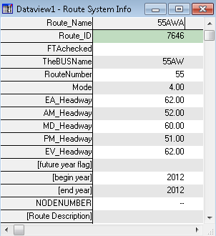
Table 9: Transit Network Attribute Data
Field Name | Field Description
Route_ID | Automatically assigned ID by TransCAD
Route_Name | Bus Route ID-future year designated with “f” at the end
TheBUSName | The Route ID as Designated by “The BUS”
RouteNumber | Numerical ID of the Route Number
Mode | Mode designation Local Bus= 4, Express Bus = 5, Limit Stop Bus = 6, Fixed Guideway = 8 Water Taxi = 8 Ferry = 8
EA_Headway | Early AM route headway in minutes (0= no route in this period)
AM_Headway | AM route headway in minutes (0= no route in this period)
MD_Headway | Midday route headway in minutes (0= no route in this period)
PM_Headway | PM route headway in minutes (0= no route in this period)
EV_Headway | Evening/Night route headway in minutes (0= no route in this period)
future year flag | Designates if route is for future horizon year (designated by “y”)
begin year | Opening year for transit route operation
end year | Closing year for transit route operation (after which the transit route will not be included in the transit network)

Figure 6: 2005 Oahu Transit Network
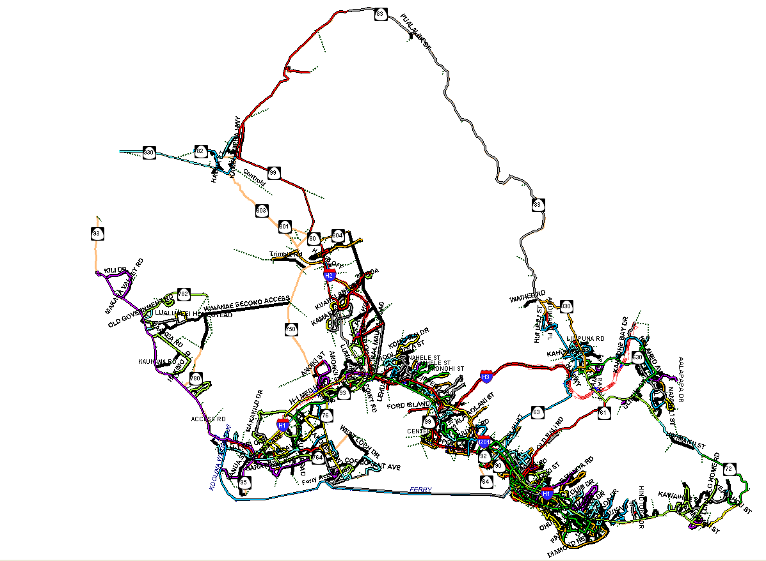

4.2.1 Adding a new transit route

Whenever a new transit route is added in the future, it has to be incorporated in the master route system. Adding a new transit route to the master route system is a two stage process; first the user has to manually code the route in the master route system using the map editor, and then the user has to fill in the attribute data for the new route. As mentioned above, all the transit route attributes have to be manually filled in.

The new transit route will be incorporated into the scenario route system for every year following the year it has been added to the master route system. This will be done using the “begin year” and “end year” attributes, e.g. if a new transit route will be added in 2015, then the “begin year” and “end year” attributes have to be appropriately specified as shown below.

New Route:
Begin year: 2015
End year: 2030

4.2.2 Modifying an existing transit route

When an existing transit route is modified or improved e.g. changing/increasing the frequency, from a future year, the user has to terminate the old transit route when the improvement has been made and add a new transit route starting when the improvement has been made. E.g. if the AM and PM frequency of an existing transit route (beginning from 2005) is improved from 30 min to 15 min from year 2015 the following changes have to be made, as shown below.

OLD Transit Route:
Begin year: 2005
End year: 2015
EA_Headway: 45 min
AM_Headway: 30 min
MD_Headway: 60 min
PM_Headway: 30 min
EV_Headway: 45 min

New Transit Route:
Begin year: 2015
End year: 2030
EA_Headway: 45 min
AM_Headway: 15 min
MD_Headway: 60 min
PM_Headway: 15 min
EV_Headway: 45 min

All of the other mandatory attributes (for the new transit route) specified in the previous section need to be filled out as well.

4.3 Traffic Analysis Zones

There is only one traffic analysis zone (TAZ) layer, called the “master TAZ layer”, for all the planning horizon years, unlike the highway network and transit route system. However, the data corresponding to the TAZ layer varies from year to year. TAZ data for each planning horizon year is stored in a spreadsheet named “y+year+tazdata” under “generic\inputs\taz\year” directory, e.g. the TAZ data for year 2030 is stored in “y2030tazdata.xls” spreadsheet under “generic\inputs\taz\2030” directory. The TAZ data for any study year essentially consists of zonal employment by category and zonal population by category. The TAZ layer is shown in Figure 7. The list of zonal attributes, in the spreadsheet, used as inputs are listed in Table 10. All of the zonal attributes listed in Table 10 have to be entered by the user as an input. This file also needs to be stored as a comma separated file (tazdata.csv) for input into the tour based models.

Table 10: TAZ Spreadsheet Data (.\generic\inputs\taz\YYYY\yYYYYtazdata.xls)
Field Name | Field Description
TAZ | TAZ number
POP | Population in TAZ
GQ | Number of group quarters in TAZ
HR | Number of hotel rooms
RC | Number of Resort Condos (housing units held for use by visitors)
HU | Number of housing units
HH1 | Number of households with 1 person
HH2 | Number of households with 2 person
HH3 | Number of households with 3 person
HH4 | Number of households with 4 person
HH5 | Number of households with 5+ person
MILI | Military employment
GOVT | government employment
HOTEL | hotel employment
AG | agricultural employment
TCU | Wholesale, transportation, communication, & utilities employment
INDUS | manufacturing employment
FIRE | Finance, insurance, & real estate employment
SERV | service employment
RETAIL | retail employment
CSTR | construction employment
TOTALEMP | Total employment
TOTALHH | Total number of households
TERMTYPE | The type of terminal, residential or downtown.
TERMTIME | The time, in minutes, taken to get from the car(parking) to the destination(door) or the time taken from the origin (door) to the car (parking)
WK_PKCOST | Weekday parking cost
NW_PKCOST | Weekend parking cost
PERCWLK | Percent of the zone that is within the walk distance to the transit service.
PRV_UNIV_ENROLL | Number of students enrolled in private university
PUB_UNIV_ENROLL | Number of students enrolled in public university
PRV_K12_ENROLL | Number of students enrolled in private school
PUB_K12_ENROLL | Number of students enrolled in public school
SCHOOLS | Number of schools
GQWRK | Workers from the group quarters
NONVISRET | Non visitor retail employment
VISPRCAUTO | Percent of visitors who have auto mode available
VISPRCTOUR | Percent of visitors who are on a tour
MILI_BASE | Identifier for a military zone (military zone = 1)
GQTYPE | Group Quarter Type: 1 = University/College, 2 = Military, 3 = Other non-institutional, 4 = institutional
TD | 764 TAZS to 26 District lookup
SHRWRKPKGPROVIDED | Share of workers that have parking provided at work place

Besides the zonal attributes being imported from the spreadsheets, there are other zonal attributes in the “master TAZ layer”, listed in Table 11. Among the attributes in the master line layer only one attribute (highlighted in green) is mandatory and required to be input by the user, rest of the attributes are either (1) automatically generated by TransCAD when the zone is created or (2) used for comparison purposes, highlighted in blue, or (3) computed in the process of modeling.

Table 11: TAZ Layer Attribute Data
Field Name | Field Description
ID | TransCAD Automatic link ID
Area | Area of TAZ- automatically calculated
TAZ | TAZ number
AREA_SQFT | Area of TAZ in ft²
TD | District number
BASEYR_POP | Population of TAZ in the base year
BASEYR_GQ | Number of group quarters in TAZ in the base year
BASEYR_HR | Number of hotel rooms
BASEYR_RC | Number of Resort Condos (housing units held for use by visitors)
BASEYR_HU | Number of housing units
BASEYR_HH1 | Number of households with 1 person
BASEYR_HH2 | Number of households with 2 person
BASEYR_HH3 | Number of households with 3 person
BASEYR_HH4 | Number of households with 4 person
BASEYR_HH5 | Number of households with 5+ person
BASEYR_MILI | Military employment
BASEYR_GOVT | Government employment
BASEYR_HOTEL | Hotel employment
BASEYR_AG | Agricultural employment
BASEYR_TCU | Wholesale, transportation, communication, & utilities employment
BASEYR_INDUS | Manufacturing employment
BASEYR_FIRE | Finance, insurance, & real estate employment
BASEYR_SERV | Service employment
BASEYR_RETAIL | Retail employment
BASEYR_CSTR | Construction employment
BASEYR_TOTALEMP | Total employment in the base year
BASEYR_TOTALHH | Total number of households in base year
EMP_DEN | Employment density
POP_DEN | Population density
ATYPE | Area type
Note: Shaded fields are used for comparison of scenario year to base-year and not for modeling.

Figure 7: TAZ Layer
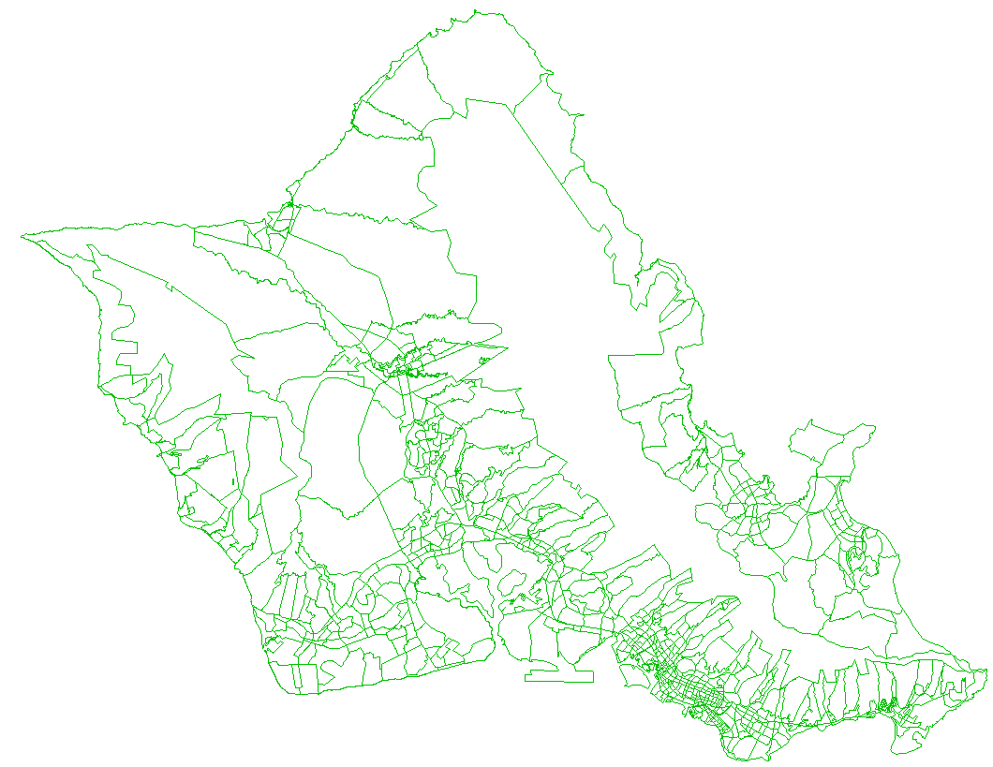

4.4 Urbansim Data

Two Urbansim files are needed in the inputs/TAZ directory. They are the households.csv, and the persons.csv files. These are called the population synthesizer generated files, where every household and person is synthesized for Oahu.

The following two tables are the variables generated in each file.

Table 12. Urbansim Synthesized Households.csv file
Variable | Variable Definition | Categories | Category Definition
household_id | unique UrbanSim identifier for households | 1..n
age_of_head | Age of head of household | 18..93
building_id | UrbanSim foreign key linking household to building | 1..n
building_size | Size of building | 1 | Mobile home or trailer
 |  | 2 | One-family house detached
 |  | 3 | One-family house attached
 |  | 4 | 2 Apartments
 |  | 5 | 3-4 Apartments
 |  | 6 | Apartments
 |  | 7 | 10-19 Apartments
 |  | 8 | 20-49 Apartments
 |  | 9 | 50 or more apartments
 |  | 10 | Boat, RV, van, etc.
building_type_id | Building type for assignment of residential units and non-residential sq ft | 1 | Single-family
 |  | 2 | Townhouse
 |  | 3 | Apartment
 |  | 4 | Hotel
 |  | 5 | Resort
 |  | 6 | Industrial
 |  | 7 | Warehousing/Shipping
 |  | 8 | Office
 |  | 9 | Retail Neighborhood/Street Access
 |  | 10 | Community/Classroom/Hospital
 |  | 11 | Other
children | Number of children in household | 0 | No children in household
 |  | 1..10 | Total children in household
dpa_id | Development Plan Area identifier | 10 | Primary Urban Center
 |  | 20 | Ewa
 |  | 30 | Central Oahu
 |  | 40 | East Honolulu
 |  | 50 | Koolaupoko
 |  | 60 | Koolauloa
 |  | 70 | North Shore
 |  | 80 | Waianae
family_type |  | 1 | Family household
 |  | 2 | Non-family household
group_quarters |  | 0 | Non-group quarters
household_zone | Transportation Analysis Zone (TAZ) identifier | 1..764
housing_rent | Monthly rent for housing unit | 0 | Non-renting household
 |  | 1..9999 | Monthly rent paid
income | Total household income | 0 | No income
 |  | -999999..99999999 | Total income in dollars
orig_tenure | Ownership/Rental status of household | 1 | Owned with mortgage or loan
 |  | 2 | Owned free and clear
 |  | 3 | Rented for cash rent
 |  | 4 | No cash rent
tenure | Own vs. rent status | 1 | Own
 |  | 2 | Rent
original_block_group | Census block group identifier (within tract) | 1..9
original_geography_id | Census tract and block group code | 1021..113022
persons | Number of persons in household (top-coded) | 1..4 | number of persons 1-4
 |  | 5 | top-coded, 5+ persons
persons_total | Number of persons in household | 1..16 | number of persons 1-16
property_value | Income group | 1 | Less than $10,000
 |  | 2 | $10,000 to $14,999
 |  | 3 | $15,000 to $19,99
 |  | 4 | $20,000 to $24,999
 |  | 5 | $25,000 to $29,999
 |  | 6 | $30,000 to $34,999
 |  | 7 | $35,000 to $39,999
 |  | 8 | $40,000 to $49,999
 |  | 9 | $50,000 to $59,999
 |  | 10 | $60,000 to $69,999
 |  | 11 | $70,000 to $79,999
 |  | 12 | $80,000 to $89,999
 |  | 13 | $90,000 to $99,999
 |  | 14 | $100,000 to $124,999
 |  | 15 | $125,000 to $149,999
 |  | 16 | $150,000 to $174,999
 |  | 17 | $175,000 to $199,999
 |  | 18 | $200,000 to $249,999
 |  | 19 | $250,000 to $299,999
 |  | 20 | $300,000 to $399,999
 |  | 21 | $400,000 to $499,999
 |  | 22 | $500,000 to $749,999
 |  | 23 | $750,000 to $999,999
 |  | 24 | $1,000,000 or more
pums_serialno | Identifier for PUMS household record | 1..99999999
tract00 | 2000 Census Tract identifier
tract_id_real | 2010 Census Tract identifier
vehicles |  | 0 | No vehicles
 |  | 1..5 | 1 to 5 vehicles
 |  | 6 | 6 or more vehicles
workers | Number of workers in household | 0 | No workers
 |  | 1..10 | Number of workers in household
year_built | Year unit was constructed | 1 | 1999 to 2000
 |  | 2 | 1995 to 1998
 |  | 3 | 1990 to 1994
 |  | 4 | 1980 to 1989
 |  | 5 | 1970 to 1979
 |  | 6 | 1960 to 1969
 |  | 7 | 1950 to 1959
 |  | 8 | 1940 to 1949
 |  | 9 | 1939 or earlier
year_moved |  | 1 | 1999 or 2000
 |  | 2 | 1995 to 1998
 |  | 3 | 1990 to 1994
 |  | 4 | 1980 to 1989
 |  | 5 | 1979 or earlier

Table 13. Urbansim Synthesized Persons.csv file
Variable | Variable Definition | Categories | Category Definition
age | Age of person | 0..93
block_group | Census block group identifier (within tract)
earnings | Person's individual earnings | -10000..999999 | -10,000-999,999 in dollars
education | Educational Attainment | 0 | Not in universe (Under 3 years)
 |  | 1 | No schooling completed
 |  | 2 | Nursery school to 4th grade
 |  | 3 | 5th grade or 6th grade
 |  | 4 | 7th grade or 8th grade
 |  | 5 | 9th grade
 |  | 6 | 10th grade
 |  | 7 | 11th grade
 |  | 8 | 12th grade, no diploma
 |  | 9 | High school graduate
 |  | 10 | Some college, but less than 1 year
 |  | 11 | One or more years of college, no degree
 |  | 12 | Associate degree
 |  | 13 | Bachelor’s degree
 |  | 14 | Master’s degree
 |  | 15 | Professional degree
 |  | 16 | Doctorate degree
employment_status |  | 0 | Not in universe (Under 16 years)
 |  | 1 | Employed, at work
 |  | 2 | Employed, with a job but not at work
 |  | 3 | Unemployed
 |  | 4 | Armed Forces, at work
 |  | 5 | Armed Forces, with a job but not at work
 |  | 6 | Not in labor force
gender | Gender of person | 1 | Male
 |  | 2 | Female
household_id | UrbanSim foreign key linking household to building | 1..n
industry |  | 0 | Not in universe
 |  | 10000000..99999999 | Industry NAICS code
mode_to_work | Mode of travel to work | 0 | Not in universe (Under 16 years)
 |  | 1 | Car, truck, or van
 |  | 2 | Bus or trolley bus
 |  | 3 | Streetcar or trolley car
 |  | 4 | Subway or elevated
 |  | 5 | Railroad
 |  | 6 | Ferryboat
 |  | 7 | Taxicab
 |  | 8 | Motorcycle
 |  | 9 | Bicycle
 |  | 10 | Walked
 |  | 11 | Worked at home
 |  | 12 | Other method
occupation |  | 0 | Not in universe (Under 16 years)
 |  | 001..997 | Legal census occupation code
person_id | unique UrbanSim identifier for households | 1..n
pums_pnum | PUMS person order within household | 1..16
pums_serialno | PUMS person record identifier
relation |  | 1 | Householder
 |  | 2 | Husband/wife
 |  | 3 | Natural born son/daughter
 |  | 4 | Adopted son/daughter
 |  | 5 | Stepson/stepdaughter
 |  | 6 | Brother/sister
 |  | 7 | Father/mother
 |  | 8 | Grandchild
 |  | 9 | Parent-in-law
 |  | 10 | Son-in-law/daughter-in-law
 |  | 11 | Other relative
 |  | 12 | Brother-in-law/sister-in-law
 |  | 13 | Nephew/niece
 |  | 14 | Grandparent
 |  | 15 | Uncle/aunt
 |  | 16 | Cousin
 |  | 17 | Roomer/boarder
 |  | 18 | Housemate/roommate
 |  | 19 | Unmarried partner
 |  | 20 | Foster child
 |  | 21 | Other nonrelative
 |  | 22 | Institutionalized GQ person
 |  | 23 | Noninstitutionalized GQ person
school_enrollment |  | 0 | Not in universe (Under 3 years)
 |  | 1 | No, has not attended since February 1
 |  | 2 | Yes, public school or college
 |  | 3 | Yes, private school or college
tract | Census 2000 tract code
work_hours | Usual hours worked per week | 1..98 | 1 to 98 usual hours
 |  | 99 | 99 or more usual hours
work_type | Class of worker | 1 | Employee of private for-profit company
 |  | 2 | Employee of private not-for-profit company
 |  | 3 | Employee of local government
 |  | 4 | Employee of state government
 |  | 5 | Employee of federal government
 |  | 6 | Self-employed in unincorporated business or company
 |  | 7 | Self-employed in incorporated business or company
 |  | 8 | Unpaid family worker
 |  | 9 | 15 and younger
 |  | 10 | In armed forces
 |  | 11 | Unemployed
 |  | 12 | Not in labor force
worker | Worker or non-worker | 0 | Non-worker
 |  | 1 | Worker

Graphical User Interface (GUI)
The GUI developed for OahuMPO conveniently allows the user to run the model with the touch of a button, without going into the programs used to run the model. The GUI closely follows the stages in the model and gives user the option of either running one stage of the model at a time or running the entire model system by the push of a button.

5.1 GUI Components
There are 3 key dialog boxes in the GUI developed for OahuMPO models:
- OAHU Model dialog box: This is the main dialog box, shown in Figure 8, and appears when the model is launched. This dialog box has three main sections:
              - Scenario Directory: is used to either browse for the scenario directory if the scenario is already setup, or it is used to setup the scenario if it is not already done.
              - OPTIONS: The GUI provides several options to the user to control the way OahuMPO models are run.
              - STAGES: The entire 4-step model is run from this section. In this section each step in the model can be run by the click of a button.
- Scenario Manager dialog box: The scenario manager, shown in Figure 9, is used to create the zonal layer, highway network, and transit route system for the scenario year. It can also be used to copy an existing scenario to a new directory. This dialog box has three main sections:
              - Inputs: This section collects information about the scenario year and also lets the user to navigate to the Inputs dialog box and gather the path of various input files.
              - Scenario Directory: This section lets the user browse for the scenario directory. All the files corresponding to the scenario year (or study year) are created in the scenario directory.
              - Create Scenario Data: In this section the user can create the TAZ layer, highway network, and transit route system for a given scenario year. Zonal data for a given scenario year can be created by clicking the “Create TAZ Data” button. A highway network and transit route system for the scenario year can be created by clicking the “Create Network” button. In order to create either the TAZ layer or highway network or transit route system for a given scenario year, information about the location of the master TAZ layer, master highway network, master route system, and scenario year has to be collected first.
- Inputs dialog box: The inputs dialog box, shown in Figure 10, is used to collect information about the location of folders that contain key inputs in the modeling process. Several options are available to the user to gather the location of the folders listed above:
              - The user can manually browse for each of these folders.
              - The user can set default paths for all of the above folders by clicking “Set all directories to default” button.
              - The user can manually browse for the generic directory and set all the path of all the other folders based on the generic directory. This can be done by first browsing for the generic directory and then clicking “Set Directories using Generic”.

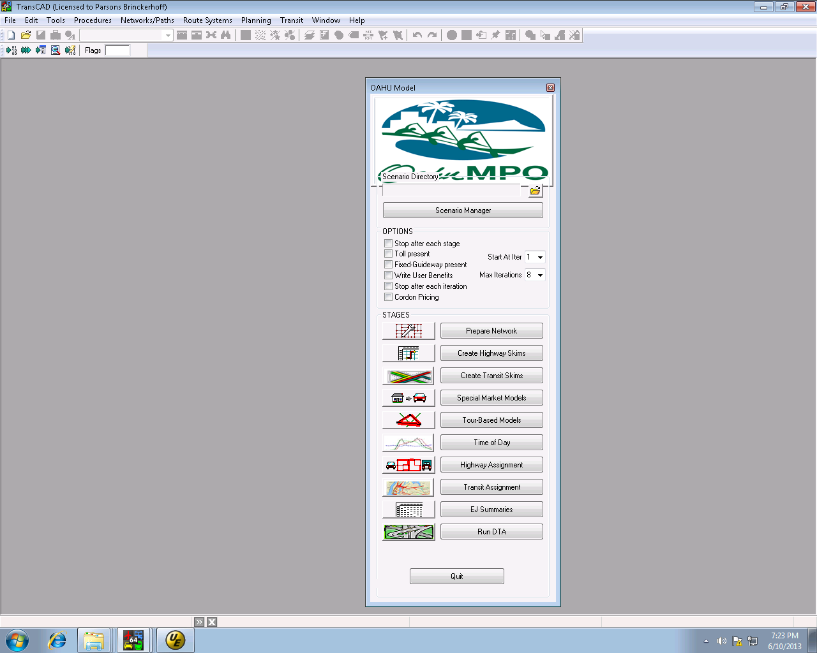
When this button is clicked scenario manage dialog box is shown.
When this button is clicked transit assignment step is carried out.

When this button is clicked the DTA assignment is run.

When this button is clicked environmental justice summaries are prepared.

When this button is clicked highway assignment step is carried out.

When this button is clicked time of day step is carried out

When this button is clicked the tour based models are run (residential and visitor)
When this button is clicked the special market models are run (truck and air passenger)
STAGES Section
OPTIONS Section
Scenario Directory
Section
When this button is clicked two tasks are carried out, first the line layer is updated and then the highway network is created.
When this button is clicked the highway skims are generated
When this button is clicked the transit skims are generated
Figure 8: GUI For OahuMPO Planning Model

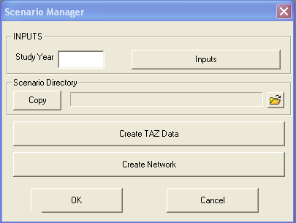
Create Scenario Section

Scenario Directory
Section

When this button is clicked Inputs dialog box is shown.
When this button is clicked Highway network and transit route system for the scenario year is created.

When this button is clicked Zonal data for a given scenario year is created.

INPUTS Section

Figure 9: Scenario Manager Dialog Box

Figure 10: Inputs Dialog Box
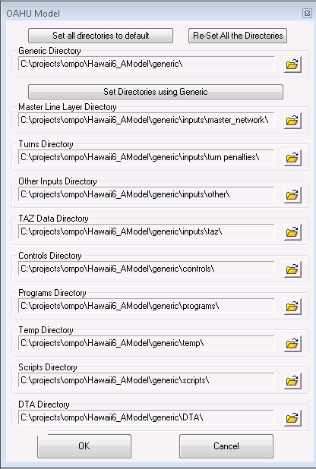
When this button is clicked all of the directories are set using the generic directory.
When this button is clicked all of the directories are set to null.
When this button is clicked all the directories are set to default.

5.2 Launching the GUI
All the model scripts need to be compiled before they are used from the GUI. Thus, all the model scripts along with the GUI script are added to a list file called “ompo6.lst”, which is located under “generic\scripts\ompo6.lst”. Compiling this list file automatically compiles all the scripts used in the model. The sequence of steps required to compile the model scripts are described below:
- Compile the generic\scripts\ompo6.lst to a database in the same directory called "ompo6.dbd".
  - Hit the compile to UI button, as shown below. Then choose the “generic\scripts\ompo6.lst” file and save it as “generic\scripts\ompo6.dbd”.
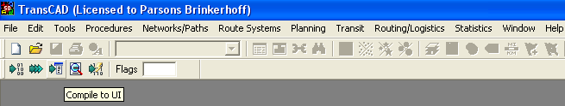
- Launch TransCAD, and then choose Tools Setup Addins. This will bring up the setup add-ins dialog box as shown below.
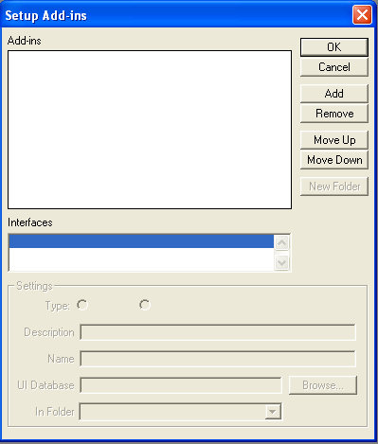
- Click Add button to add a new add-in.
- In the settings frame of the Setup add-ins dialog box
  - Choose the Dialog box radio button
  - Type in “OMPO 6 Models” under description
  - Type in “Oahu Model” under name
  - Browse and select generic\scripts\ompo6.dbd for UI database
  - Click the Dialog Box button. The screen should look as shown below
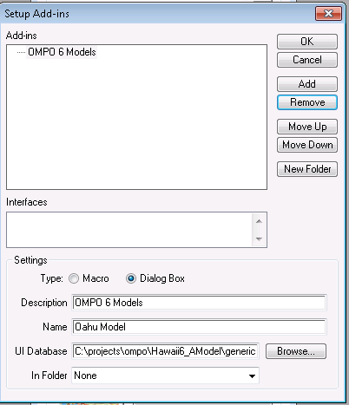

- Click OK.
- Go to Tools-Addins and select OMPO 6 Models. The main dialog box of GUI should appear on your screen, as shown in Figure 8.

5.3 GUI Navigation

In order to run the OahuMPO model for a given scenario year, the scenario has to be setup. To set up a scenario, first the scenario year and location of folders that contain key inputs required for creating a scenario has to be obtained. The GUI separates modeling a scenario into three main stages:
- Gathering inputs
- Setting up the scenario
- Running the model for a scenario

Three separate dialog boxes are used to perform the above tasks. The sequence of dialog boxes is shown in Figure 11. The inputs dialog box is used to collect the location of all the important folders that contain the model inputs. The inputs dialog box is called from the scenario manager dialog box. The scenario manager is used to setup the zonal layer, highway network, and transit route system for the scenario year. The scenario manager is called from the main dialog box, shown in Figure 11. Once the scenario is set up, the models for this scenario are run using controls from the main dialog box.

Figure 11: GUI Navigation

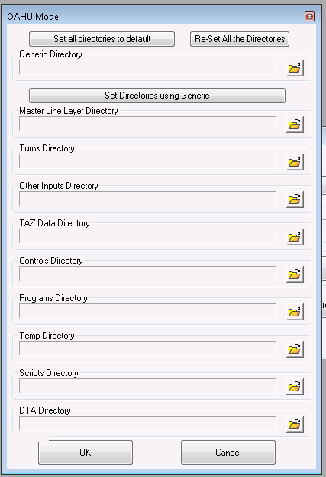

5.4 Creating a Scenario

Before the model is run for a particular scenario, the scenario first needs to be created. The creation of a scenario essentially involves creation of the scenario TAZ layer, the scenario line layer, and the scenario route system. Additionally, the scenario directory structure is created and inputs (including control files, executables, and other inputs) are copied from the generics folder (or other folders as defined by the user) to the scenario folder. To create a scenario, the study year and the location of all the input files must be collected trough the inputs dialog box. The sequence of steps required to create a scenario are listed below:
- Launch TransCAD and the GUI
- In the main GUI dialog box (OAHU Model) click the “Scenario manager” button. This will bring up the “Scenario manager” dialog box.
- In the scenario manager dialog box, enter the study year. Then click the “Inputs” button. This will bring up the “Inputs” dialog box.
- In the inputs dialog box, either browse for the all the input folders manually or hit “Set all directories to default” button. This will gather information about the paths of all the input folders.
- Click the “OK” button in the inputs dialog box. This will close the “Inputs” dialog box and give the control back to “Scenario manager” dialog box.
- In the scenario manager dialog box, browse for the scenario directory. If the scenario directory is not already created, you can create a new folder from the browse dialog box. Scenario directory can be placed anywhere and can be named anything, however, it is advisable to name it such that it represents the study year and the scenario. Once the scenario directory is chosen, all the inputs required to create a scenario are gathered.
- Click the “Create TAZ data” button to create the scenario TAZ layer.
- Next, click the “Create Network” button to create the scenario line layer and the scenario route system. This completes the creation of the scenario.
- Click “OK” button in the scenario manager dialog box, this will close the scenario manger dialog box and give the control back to the “OAHU Model” dialog box.

5.4 Running a Scenario

The OMPO6.0 model is run from the “OAHU Model” dialog box. It is customary to run all the models sequentially and iteratively until convergence. However, the GUI developed for OMPO6.0 model gives the user a great level of control on the way that the model is run. The “OPTIONS” section of the “OAHU Model” dialog box provides the user several alternatives, which are explained in Table 14 below.

Table 14: Options for running the OahuMPO models

To Do This | Do This (In the “OPTIONS” section)
Run one step of the model | Check the “Stop after each stage” option.
Run the models iteratively but stop after each iteration | Check the “Stop after each iteration” option.
Run the entire model set until convergence | Uncheck the “Stop after each iteration” and “Stop after each stage” options.
Run the models with tolls | Check the “Toll present” option.
Run the models with fixed guide way transit | Check the “Fixed-Guideway present” option.
Report user benefits | Check the “User benefits” option.
Start the model run from “k^{th}” iteration | Select “k” from the “start at iteration” drop down menu.
Run the model for “k” iterations if it doesn’t converge | Select “k” from the “Max iterations” drop down menu.

The comprehensive set of options listed above enable the user to customize the way models are run, according to his needs. Once the options are selected the next step is to run the models.

If the user chooses to run the entire model set until convergence, then the user must click on the very first step of the models, which is “Prepare Network”. If the user chooses to run the model iteratively but stop after each iteration, the user can also click on the very first step of the models. After the model runs for an iteration, convergence test is performed in the feedback loop. If the model did not converge, all the output files generated from that iteration are moved to a separate folder named “iterN” (under outputs folder: .\Scenario folder\Outputs\iterN) for “N^{th}” iteration and if the model does converge, the output files generated from that iteration are left in the outputs folder and these outputs are treated as final outputs. If the user chooses to run the model one step at a time, then the user has to sequentially go over all the model steps. A brief listing of the inputs, outputs and method used for running each step of the model is described below.

5.4.1 Prepare Network

When the user clicks the “Prepare Network” button three GISD-K scripts are executed, which are listed below:
- UpdateLineLayer.rsc: The area type, free flow speed, congested speed, capacity fields, transit peak travel time, transit off peak travel time, and alpha parameter field which is used for the volume delay functions for each link are computed and filled with the new values. The input files and output files for this task are listed below:
Input Files:
Hwyfile: Scenario line layer
Tazfile: Scenario TAZ layer
Fspeedfile: Free flow speed look-up table (Table 17)
Cspdfile: Congested speed look-up table (Table 18)
Capfile: Capacity look-up table (Table 19)
Conicalsfile: Parameters in the volume delay function (Table 20)
Trnpkfactfile: Transit peak travel time factors (Table 21)
Trnopfactfile: Transit off peak travel time factors (Table 22)
Output Files: Hwyfile: An updated scenario line layer with new values of area type, free flow speed, congested speed, capacity, transit peak travel time, transit off peak travel time, and alpha parameter for the volume delay functions for each link.

To begin the travel demand process, an estimate of free flow speed and congested speeds is required. The free flow speed table, congested speed table, capacity table, and transit factor tables are used to insert the speed and capacity values into the link records based on the area type and facility type of the link. The facility types are listed in Table 15: Facility Types. The area type is calculated based on a floating population density and employment density for every TAZ within ½ mile of every zone centroid. The employment categories and population density categories that define each area type are shown below in Table 16. All of the look-up tables are in TransCAD binary format, so they can be opened only through TransCAD.

Table 15: Facility Types
Facility Type Code | Description
1 | Freeways
2 | Expressways
3 | Class-1 Arterials
4 | Class-2 Arterials
5 | Class-3 Arterials
6 | Class-1 Collectors
7 | Class-2 Collectors
8 | Local Streets
9 | High Speed Ramps
10 | Low Speed Ramps
12 | Centroid Connectors
13 | HOV Lanes
14 | Transit Only Lanes
197 | Walk Access Lanes

Table 16: Area-Type Definitions Based on Population and Employment Densities*
Employment Category (Employees per Square Mile) | ≤12 | ≤93 | ≤397 | ≤1,615 | ≤6,202 | ≤22,630 | ≤78,500 | >78,500
Population Category (Population per Square Mile)
0 | 8 | 8 | 7 | 6 | 4 | 4 | 2 | 1
≤192 | 8 | 8 | 6 | 6 | 4 | 4 | 2 | 1
≤1,623 | 7 | 7 | 7 | 6 | 4 | 4 | 2 | 1
≤4,975 | 7 | 7 | 7 | 7 | 4 | 4 | 2 | 1
≤11,588 | 5 | 5 | 5 | 5 | 5 | 4 | 2 | 1
≤24,000 | 5 | 5 | 5 | 5 | 5 | 5 | 2 | 1
≤42,866 | 3 | 3 | 3 | 3 | 3 | 3 | 3 | 1
>42,866 | 3 | 3 | 3 | 3 | 3 | 3 | 3 | 1

*Another special area type -- 9 is coded for military area, as the trip rates of military area significantly differ from the other area types. In the update line layer step of the model, the area type of all zones is calculated using the employment and population densities. However, in the trip generation step, all the military zones are identified and their area type is replaced as “9”.

Table 17: Free-Flow Speed Look-up Table (\generic\inputs\other\ FSPED.bin)
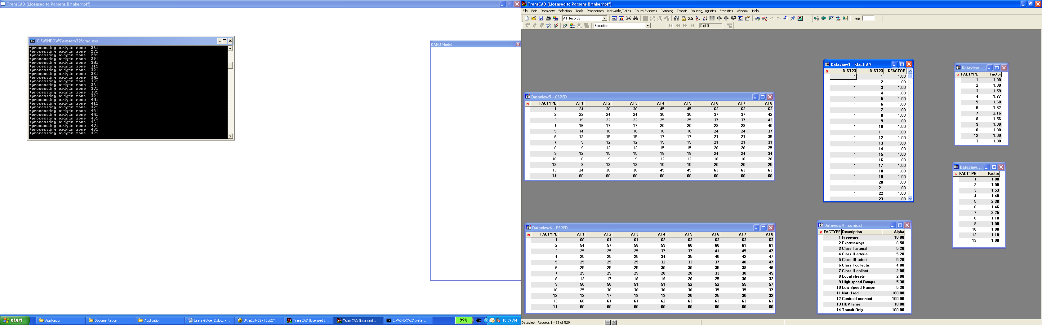

Table 18: Congested Speed Look-up table (\generic\inputs\other\ CSPED.bin)
Table 19: Capacity Look-up Table (\generic\inputs\other\ ACAPA.bin)
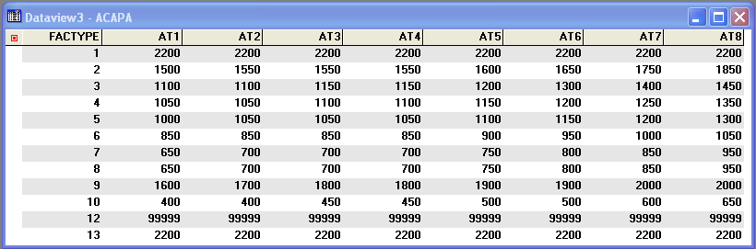

Table 20: Alpha Parameters in the Volume Delay Function
(\generic\inputs\other\ conical.bin)

Table 21: Transit Peak Travel Time Factors (\generic\inputs\other\ TRANPKTIMEFAC.bin)

Table 22: Transit Off-Peak Travel Time Factors
(\generic\inputs\other\ TRANOPTIMEFAC.bin)

- CreateHighwayNetwork.rsc: This GISD-K script creates a highway network for use in the first iteration of the model system. The input files and output files for this task are listed below:
Input Files:
Hwyfile: Scenario line layer
Output Files
Hnetfile: Highway network
- TransitAccessLinks.rsc: This GISD-K script creates walk access links from each centroid to the nearest bus transit stops. The script also creates a PNR and a KNR centroid to highway node skim matrix that is used for transit drive skims. The algorithm used in the creation of the links and connection of the centroids to highway nodes is intelligent in that access is only built to nodes that provide route service that isn’t already provided by an existing, closer link. The thresholds that are currently in place which restrict the number of links and maximum connection distance by access mode are given in Table 23. These parameters are currently hard-coded in the GISD-K script. Note that it is possible for the transit path-finder to walk along links in the highway network to access other transit stops that do not have a direct connection according to access links provided. The input files and output files for this task are listed below:
Input Files:
Hwyfile: Scenario line layer
Rtsfile: Route system file
Output Files:
Hwyfile: Updated scenario line layer with transit access links.
pnracc.mtx: PNR centroid to highway node matrix (length, peak time, and off-peak time)
knracc.matx: KNR centroid to highway node matrix (length, peak time, and off-peak time)

Table 23: Link and Distance Thresholds Used in Transit Access Connections
Access Mode | Max. Number of Links | Max. Distance (mi)
Walk | 10 | 2
PNR | 6 | 8
KNR | 4 | 8

5.4.2 Create Highway Skims

When the user clicks the “Create Highway Skims” button, the HighwaySkims.rsc GISD-K script is run. For each O-D pair in the highway network least cost paths are computed and the corresponding skims are created. In OahuMPO models, generalized least cost is used for skimming. This generalized cost comprises of time, distance, and turn penalties. In order to generate a single cost a value of 15 $/hr is used as the value of time and a value of 0.12 $/mi is used as the value of distance. The skimming process takes into account the presence of tolls and accordingly generates skims for scenario with tolls if the “tolls present” option is selected in the OPTIONS section of the GUI. Highway non-toll skims include: congested travel time, length, initial congested travel time. If tolls are present, additional skims are computed which are: the total toll for each O-D pair for SOV, HOV2, and HOV3+ vehicles. The input files and output files for this task are listed below:
Input Files:
Hwyfile: Scenario line layer.
Tpen: Turn penalties file.
Iftoll: A binary variable used as an indicator for the presence of tolls.
Output Files:
hwy<time period>_sov.mtx: O-D matrix for single occupancy vehicles in <time period> where time period is EA (early AM), AM (AM Peak period), MD (midday period), PM (PM Peak period), EV (evening period) consisting of several cores (minutes, distance in miles)
hwy<time period>_hov2.mtx: O-D matrix for 2 occupancy vehicles in <time period> consisting of several cores, as described above except for 2 occupant vehicles (which can use 2+ HOV lanes).
hwy<time period>_hov3.mtx: O-D matrix for 3+ occupancy vehicles in <time period> consisting of several cores as described above except for 3 occupant vehicles, which can use 3+ occupant HOV lanes)

If the user chooses to run a scenario with tolls (“Toll Present” selected), then additional output files are generated with toll cost and distance traveled on toll lanes. These matrix cores are then appended to the original highway files listed above so that those files contain both non-toll and toll paths for each occupancy class, similar to the MINUTP models. The matrix cores for each set of highway skims are given in Table 24.

5.4.3 Create Transit Skims

When the user clicks the “Create Transit Skims” button, the TransitSkims.rsc GISD-K script is run. First, this macro computes transit travel times from the corresponding highway travel times. In the first iteration, the coded times are used based on the lookup tables given up. In subsequent iterations, the travel times are appended from the congested times obtained by the method of successive averages. Next, skims are generated for local bus, express bus, and fixed guideway walk modes, and by park-and-ride and kiss-and-ride drive modes, using the TransCAD Pathfinder algorithm. The mode-specific weights used in path-finding are given in the transit mode table, shown in Table 25. The global parameters used in pathfinder are given in Table 26. The input files and output files for this task are listed below. The matrix cores for each set of transit skims are given in Table 24.
Input Files:
Hwyfile: Scenario line layer.
Rtsfile: Scenario route system file.
Rstopfile: Scenario transit stop layer.
Modefile: Transit mode attributes table.
Xferfile: Inter mode transfer cost table
pnracc.mtx: PNR centroid to highway node matrix (length, peak time, and off-peak time)
knracc.matx: KNR centroid to highway node matrix (length, peak time, and off-peak time)

Output Files:
- transit_wloc_<time period>.bin: Transit skims for walk to local in <time period> where time period is EA (early AM), AM (AM Peak period), MD (midday period), PM (PM Peak period), EV (evening period)
- transit_wexp_<time period>bin: Transit skims for walk to express in <time period>
- transit_wfxg_<time period>.bin: Transit skims for walk to fixed guideway in <time period>
- transit_ptw_<time period>.bin: Transit skims for park and ride access and walk egress in <time period>
- transit_wtp_<time period>.bin: Transit skims for walk access and park and ride egress in <time period>.
- transit_ktw_<time period>.bin: Transit skims for kiss and ride access and walk egress in <time period>.
- transit_wtk_<time period>.bin: Transit skims for walk access and walk kiss and ride in <time period>.

Table 24: Highway and Transit Skim Tables
Matrix | SOV, HOV2, HOV3+ | Walk Local | Walk Express | Walk Guideway | PTW | KTW | WTP | WTK
1 | Time | Fare | Fare | Fare | Fare | Fare | Fare | Fare
2 | Length | Total In-Vehicle Time | In-Vehicle Time | In-Vehicle Time | In-Vehicle Time | In-Vehicle Time | In-Vehicle Time | In-Vehicle Time
3 | Toll Path Time | Initial Wait Time | Initial Wait Time | Initial Wait Time | Initial Wait Time | Initial Wait Time | Initial Wait Time | Initial Wait Time
4 | Toll Path Length | Transfer Wait Time | Transfer Wait Time | Transfer Wait Time | Transfer Wait Time | Transfer Wait Time | Transfer Wait Time | Transfer Wait Time
5 | Toll Cost | Transfer Walk Time | Transfer Walk Time | Transfer Walk Time | Transfer Walk Time | Transfer Walk Time | Transfer Walk Time | Transfer Walk Time
6 | Toll Lane Distance | Access Walk Time | Access Walk Time | Access Walk Time | Egress Walk Time | Egress Walk Time | Access Walk Time | Access Walk Time
7 |  | Egress Walk Time | Egress Walk Time | Egress Walk Time | Access Drive Time | Access Drive Time | Egress Drive Time | Egress Drive Time
8 |  | Fare | Fare | Fare | Fare | Fare | Fare | Fare
9 |  | Dwelling Time | Dwelling Time | Dwelling Time | Dwelling Time | Dwelling Time | Dwelling Time | Dwelling Time
10 |  | Number of Transfers | Number of Transfers | Number of Transfers | Number of Transfers | Number of Transfers | Number of Transfers | Number of Transfers
11 |  |  | Local IVT | Local IVT | Drive Distance | Drive Distance | Drive Distance | Drive Distance
12 |  |  | Express IVT | Express IVT | Local IVT | Local IVT | Local IVT | Local IVT
13 |  |  | Limited IVT | Limited IVT | Express IVT | Express IVT | Express IVT | Express IVT
14 |  |  | Ferry IVT | Fixed-Guideway IVT | Limited IVT | Limited IVT | Limited IVT | Limited IVT
15 |  |  |  | Ferry IVT | Fixed-Guideway IVT | Fixed-Guideway IVT | Fixed-Guideway IVT | Fixed-Guideway IVT
16 |  |  |  |  | Parking Node |  | Parking Node

Table 25: Transit Mode Table (\generic\inputs\other\modes.bin)
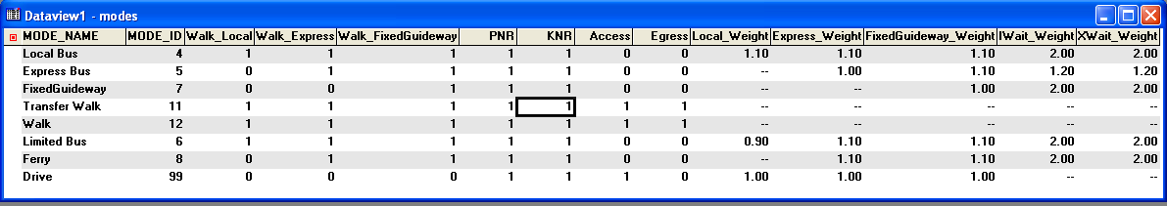
Note: Travel time fields not shown

Table 26: Global Transit Pathfinder Parameters
Parameter | Value
Global Fare Value | 68
Global Xfer Fare | 0
Global Fare Weight | 1
Global Imp Weight | 1
Global Xfer Weight | 1
Global IWait Weight | 2
Global XWait Weight | 2
Global Dwell Weight | 1
Global Dwell Time | 0.3
Global Headway | 15
Global Xfer Time | 4
Global Max IWait | 60
Global Min IWait | 2
Global Max XWait | 60
Global Min XWait | 2
Global Layover Time | 3
Global Max Access | 30
Global Max Egress | 30
Global Max Transfer | 10
Global Max Imp | 999
Path Method | 3
Value of Time | 0.2
Max Xfer Number | 2
Max Trip Time | 999
Walk Weight | 2
Zonal Fare Method | 1
Interarrival Para | 0.5
Path Threshold | 0.1
Use All Walk Path | "False"
Use Stop Access | "False"
Use Mode | "True"
Use Mode Cost | "True"
Combine By Mode | "True"
Fare By Mode | "False"
M2M Fare Method | 2
Fare System | 1

5.4.4. Special Market Models

When the user clicks the “Special Market Models” button, the first part that is run is the TripGen.rsc GISD-K script. The trip generation step estimates trip-ends for each zone as a function of the activity in that zone represented by the number of employees and the number of housing units for the truck model, and the number of hotel rooms, households, and airport emplanements for the air passenger model. Trip generation is implemented in a series of stand-alone executables written in the FORTRAN programming language. These programs were converted to read TransCAD binary files, ASCII land-use data files, and other inputs consistent with the TransCAD model system.
Input Files:
Tazfile: Scenario TAZ layer
HNL5SPGN.exe: Program file for truck trips.
TRKGEN5.ctl: Control file for truck trips, shown in Figure 12
AIRGEN5.ctl: Control file for airport trips, shown in Figure 13.

Figure 12: Truck Trip Generation Control File (TRKGEN5.CTL)
OMPO Model Development Project
Trip Generation for Trucks

&files
fzdata = '.\inputs\taz\Scenario TAZ Layer.ASC'
ftends = '.\outputs\trckends.dat'
frpt = '.\reports\hnl5trkg.rpt'
title = 'apply truck-trip generation model '
&end
NOTE: Replace %%% with 3-character alternative specification

&params
nzones = 764
npurps = 7
nzdata = 68
zspec = 234, 330, 331, 332, 347, 350
zdind = 52, 42, 43, 44, 45, 46, 47, 48, 49, 50, 51
&end

empl type: total mil gov hotel agr tran ind fisc svc retl const hhs
&prods
prates1 = 0.0000, 0.2118, 0.2118, 0.2118, 0.2118, 0.2118, 0.0506, 0.2118, 0.0483, 0.0645, 0.2118, 0.0000
prates2 = 0.0000, 0.0170, 0.0170, 0.0170, 0.0170, 0.0170, 0.0064, 0.0170, 0.0000, 0.0055, 0.0170, 0.0000
prates3 = 0.0000, 0.0387, 0.0387, 0.0387, 0.0387, 0.0387, 0.0203, 0.0387, 0.0124, 0.0000, 0.0387, 0.0000
prates4 = 0.0000, 2.0000, 0.3000, 0.3000, 0.3000, 0.3000, 0.7000, 0.3000, 0.3000, 0.3000, 2.0000, 0.5000
prates5 = 0.0180, 0.0000, 0.0000, 0.0000, 0.0000, 0.0000, 0.0000, 0.0000, 0.0000, 0.0000, 0.0000, 0.0000
prates6 = 0.0336, 0.0000, 0.0000, 0.0000, 0.0000, 0.0000, 0.0000, 0.0000, 0.0000, 0.0000, 0.0000, 0.0000
prates7 = 0.0000, 0.0000, 0.0000, 0.0000, 0.0000, 0.0000, 0.0000, 0.0000, 0.0000, 0.0000, 6310.0, 0.0000
&end
For the base year the value in const prates 7 was 6310. truck trip ends
&attrs
arates1 = 0.1077, 0.0000, 0.0000, 0.0000, 0.0000, 0.0000, 0.0000, 0.0000, 0.0000, 0.0000, 0.0000
arates2 = 0.0000, 0.0212, 0.0212, 0.0212, 0.0212, 0.0212, 0.0212, 0.0212, 0.0000, 0.0000, 0.0212
arates3 = 0.0000, 0.0626, 0.0626, 0.0626, 0.0626, 0.0626, 0.0626, 0.0626, 0.0000, 0.0000, 0.0626
arates7 = 0.0000, 0.0064, 0.0064, 0.0064, 0.0064, 0.0064, 0.0000, 0.0064, 0.0000, 0.0000, 0.0064
&end

&options
detail = f
pspec = 0,0,0,0,0,0,1
recto = 1,1,1,0,0,0,1
aeqp = f,f,f,t,t,t,f
&end

Figure 13: Airport Trip Generation Control File (AIRGEN5.CTL)
OMPO Model Development Project
Trip Generation for Airport Access

&files
fzdata = '.\inputs\taz\Scenario TAZ Layer.ASC'
ftends = '.\outputs\airpends.dat'
frpt = '.\reports\airgen5.rpt'
title = 'apply airport-acc gen model '
&end
NOTE: Replace %%% with 3-character alternative specification
purposes: 1= residents, 2= visitor/tour, 3= visitor/independent

&params
nzones = 764
npurps = 3
nzdata = 71
nzdata = 71
zspec = 764
zdind = 34, 53
&end

zdat type: htlrm hld
&prods
prates1 = 0., 10000.
prates2 = 0., 16000.
prates3 = 0., 34000.
&end
Note: In the base year the second parameter of prates1 was 10000
of prates2 with 16000, of prates3 was 34000
&attrs
arates1 = 0., 1.
arates2 = 1., 0.
arates3 = 25., 1.
&end

&options
detail = f,
pspec = 1,1,1,
recto = 1,1,1,
aeqp = F,F,F,
&

Output Files:
Truckends.dat: Zone-level truck trip productions and trip attractions by trip purpose.
Airpends.dat: Zonal level airport trip productions

After the trip generation model is run, report files are created. These report files summarize the productions and attractions by trip purpose for truck trips shown in Figure 14.
Figure 14: Trip Generation Report File for Truck Trips
program tgt (version 5; 08 Mar 2008)

date: 6/27/**
time: 2:35:15
apply truck-trip generation model

rctl 601 (i) contents of control file:
&files
fzdata = .\inputs\taz\Scenario TAZ Layer.ASC
ftends = .\outputs\trckends.dat
frpt = .\reports\hnl5trkg.rpt
&params
nzones = 764
npurps = 7
nzdata = 68
zspec = 234 330 331 332 347 350
&options
detail = F
purp,recto,aeqp | rates spec? zd 52 42 43 44 45 46 47 48 49 50 51
1 1 F | prates 0 0.000 0.212 0.212 0.212 0.212 0.212 0.051 0.212 0.048 0.064 0.212
1 1 F | arates 0.108 0.000 0.000 0.000 0.000 0.000 0.000 0.000 0.000 0.000 0.000
2 1 F | prates 0 0.000 0.017 0.017 0.017 0.017 0.017 0.006 0.017 0.000 0.005 0.017
2 1 F | arates 0.000 0.021 0.021 0.021 0.021 0.021 0.021 0.021 0.000 0.000 0.021
3 1 F | prates 0 0.000 0.039 0.039 0.039 0.039 0.039 0.020 0.039 0.012 0.000 0.039
3 1 F | arates 0.000 0.063 0.063 0.063 0.063 0.063 0.063 0.063 0.000 0.000 0.063
4 0 T | prates 0 0.149 0.000 0.000 0.000 0.000 0.000 0.000 0.000 0.000 0.000 0.000
4 0 T | arates 0.000 0.000 0.000 0.000 0.000 0.000 0.000 0.000 0.000 0.000 0.000
5 0 T | prates 0 0.018 0.000 0.000 0.000 0.000 0.000 0.000 0.000 0.000 0.000 0.000
5 0 T | arates 0.000 0.000 0.000 0.000 0.000 0.000 0.000 0.000 0.000 0.000 0.000
6 0 T | prates 0 0.034 0.000 0.000 0.000 0.000 0.000 0.000 0.000 0.000 0.000 0.000
6 0 T | arates 0.000 0.000 0.000 0.000 0.000 0.000 0.000 0.000 0.000 0.000 0.000
7 1 F | prates 1 0.000 0.000 0.000 0.000 0.000 0.000 0.000 0.000 0.000 0.0006310.000
7 1 F | arates 0.000 0.006 0.006 0.006 0.006 0.006 0.000 0.006 0.000 0.000 0.006

tgt 609 (i) summary of regional reconciliation step
purp recto aeqp totprod totattr factor
---- ----- ---- ------- ------- ------
1 1 F 59074 56310 1.049
2 1 F 4062 4816 0.843
3 1 F 10733 14223 0.755
4 0 T 78009 78009 0.000
5 0 T 9411 9411 0.000
6 0 T 17567 17567 0.000
7 1 F 6309 1261 5.003
Table 27: Summary of Truck Trips by Purpose
Purpose | Total Productions | Total Attractions | factor
1 | 59074 | 56310 | 1.049
2 | 4062 | 4816 | 0.843
3 | 10733 | 14223 | 0.755
4 | 78009 | 78009 | 0.000
5 | 9411 | 9411 | 0.000
6 | 17567 | 17567 | 0.000
7 | 6309 | 1261 | 5.003

The next step after the Special Market Model trip generation is the trip distribution model. The tripdist.rsc GISD-K script is executed, and summary reports are created (trip length frequency distributions and district-level summaries) from the TripDistReport.rsc GISD-K script. The trip distribution step estimates the number of trips between each pair of zones. This step creates all zone-to-zone trip tables by linking trip-ends produced in the Trip Generation step. The input files and output files for this task are listed below:

Input Files:
- Truck Trip Files
- trckends.dat: Zone-level truck trip productions and trip attractions by trip purpose.
- trckends.dct: A user-defined dictionary file for the trckends.dat file
- comVehFF.csv: A lookup table that defines the relationship between travel distance and propensity to travel
- Airport Trip Files
- airpends.dat: Zonal level airport trip productions
- DIST5AR.CTL: Trip Distribution -- Airport-Access Trips: Residents
- DIST5AV.CTL: Trip Distribution -- Airport-Access Trips: Visitors Independent
- DIST5AT.CTL: Trip Distribution -- Airport-Access Trips: Visitors in Tours

The commercial vehicle model invokes the TransCAD gravity model routine using the GISDK script tripdist.rsc. The model uses the balanced trip production and attraction table from the previous step and distributes the trips for each commercial vehicle class separately. An OD matrix is generated for each commercial vehicle type.

Most of the input files for the airport model consist of control files. For each model step and for each trip purpose a separate control file is prepared. These files contain location of other input files and output files, parameters used in the respective model step.

Output Files:
- Truck Trip Files
- DIST5G2.mtx: Trip Distribution -- Truck Trips: Garage-based, 2-axle
- DIST5G3.mtx: Trip Distribution -- Truck Trips: Garage-based, 3-axle
- DIST5G4.mtx: Trip Distribution -- Truck Trips: Garage-based, 4-axle
- DIST5N2.mtx: Trip Distribution -- Truck Trips: Non-garage-based, 2-axle
- DIST5N3.mtx: Trip Distribution -- Truck Trips: Non-garage-based, 3-axle
- DIST5N4.mtx: Trip Distribution -- Truck Trips: Non-garage-based, 4-axle
- DIST5PO.mtx: Trip Distribution -- Truck Trips: Port-based trip table.
Airport Trip Files
- AIR_RES.bin: Trip Distribution -- Airport-Access Trips: Residents
- AIR_VIS.bin: Trip Distribution -- Airport-Access Trips: Visitors Independent
- AIR_TOUR.bin: Trip Distribution -- Airport-Access Trips: Visitors in Tours
Trip Length Frequency Distributions: Distance (miles)
- TLFD_DIST5G2_Length_ CommVeh: Truck Trips: Port-based
- TLFD_DIST5G3_Length_ CommVeh: Truck Trips: Garage-based, 2-axle
- TLFD_DIST5G4_Length_ CommVeh: Truck Trips: Garage-based, 3-axle
- TLFD_DIST5N2_Length_ CommVeh: Truck Trips: Garage-based, 4-axle
- TLFD_DIST5N3_Length_ CommVeh: Truck Trips: Non-garage-based, 2-axle
- TLFD_DIST5N4_Length_ CommVeh: Truck Trips: Non-garage-based, 3-axle
- TLFD_DIST5PO_Length_ CommVeh: Truck Trips: Non-garage-based, 4-axle
- TLFD_DIST5AR_Length_trips1: Airport-Access Trips: Residents
- TLFD_DIST5AT_Length_trips1: Airport-Access Trips: Visitors in Tours
- TLFD_DIST5AV_Length_trips1: Airport-Access Trips: Visitors Independent
Trip Length Frequency Distributions: Time (minutes)
- TLFD_DIST5G2_OPSKIMCOST_trips1: Truck Trips: Port-based
- TLFD_DIST5G3_OPSKIMCOST_trips1: Truck Trips: Garage-based, 2-axle
- TLFD_DIST5G4_OPSKIMCOST_trips1: Truck Trips: Garage-based, 3-axle
- TLFD_DIST5N2_OPSKIMCOST_trips1: Truck Trips: Garage-based, 4-axle
- TLFD_DIST5N3_OPSKIMCOST_trips1: Truck Trips: Non-garage-based, 2-axle
- TLFD_DIST5N4_OPSKIMCOST_trips1: Truck Trips: Non-garage-based, 3-axle
- TLFD_DIST5PO_OPSKIMCOST_trips1: Truck Trips: Non-garage-based, 4-axle
- TLFD_DIST5AR_OPSKIMCOST_trips1: Airport-Access Trips: Residents
- TLFD_DIST5AT_OPSKIMCOST_trips1: Airport-Access Trips: Visitors in Tours
- TLFD_DIST5AV_OPSKIMCOST_trips1: Airport-Access Trips: Visitors Independent

After the trip distribution model is complete, TransCAD generates a report, which is shown in Figure 15.
Figure 15: Trip Distribution Report File
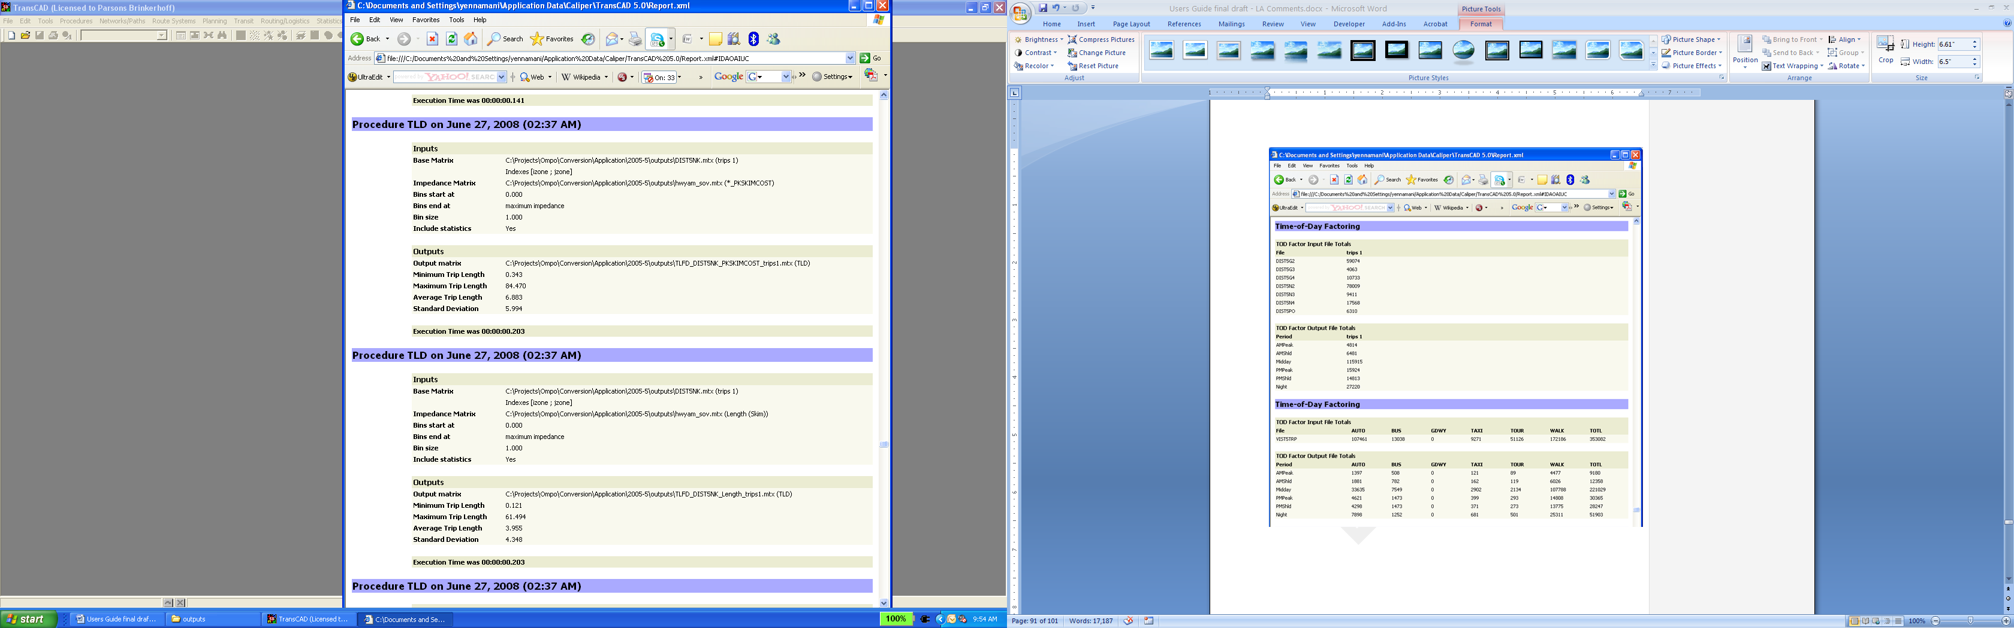

5.4.5 Tour-Based Models
When the user clicks the “Tour-Based Models” button, the residential and visitor tour-based models implemented in JAVA are run. The car ownership, tour frequency, work and school location, tour destination choice, tour mode choice, tour time of day, stop level models, and trip mode choice for both residents and visitors are run in this step.
First the residential tour based model is run. The inputs (including UECs) and outputs are listed below:

Input Files:
- TAZdata.csv
- Households.csv from Urbansim (Table 12)
- Persons.csv from Urbansim (Table 13)
- Highway and Transit skim files by time period as noted in highway and transit skimming section.
- All the UECs described in the Inputs section at the beginning of this document.
Output Files:
- Accessbilities.csv – used in most of the above mentioned models to represent accessibility to places by various tour purposes and modes.
- Households.csv includes the Urbansim household variables as well as the output of the car-ownership model where the variable autos is 0, 1, 2, or 3+.
- Persons.csv includes the Urbansim person variables as well as the estimated work location TAZ for workers, school location TAZ for students, an indicator for whether a person parks for free at their work location, and the total number of tours generated by that person.
- Tours.csv includes a profile of the tours generated by each person in the household. See Table 28 below. This includes the purpose of the tour, the time the person departed on the tour (in half hour increments starting at 3:00AM), the time the person arrived at the primary destination of the tour, the origin and primary destination TAZ of the tour, the primary mode of the tour, and the number of outbound and inbound stops on the tour. Also for all stops on the tour, the information about each stop is generated, i.e. stop is inbound (inbound = 1) or outbound (inbound = 0), mode used for that stop (see Trip Mode below), the time period, TAZ of the stop, and purpose of the stop (same code as tour purpose).
Table 28: Tours.csv Data Dictionary
hh_id | Household ID
person_id | Person ID
tour_id | Tour ID
purpose | Tour Purpose:  0 Work  1 University/College  2 School (K through 12)  3 Escorting  4 Maintenance  5 Discretionary  6 At-Work Sub Tours
departtime | Departure time of tour
arrivetime | Arrival time of tour
origintaz | Tour Origin
destinationtaz | Tour Primary Destination
tourmode | Tour Mode: 1 Drive Alone no toll –  1-occupant auto (SOV) no toll  2 Drive Alone toll – 1-occupant auto (SOV) toll lane  3 Shared Ride 2 no toll – 2-occupant auto (HOV) no toll  4 Shared Ride 2 toll – 2-occupant auto (HOV) toll lane  5 Shared Ride 3+ no toll – 3-or-more-occupant auto (HOV) no toll  6 Shared Ride 3+ toll – 3-or-more-occupant auto (HOV) toll lane  7 Walk – Walk to destination (Auxiliary  8 Bike – Bike to destination (Auxiliary  9 WK-Local – Walk to a local bus-only transit path (Walk to Transit)  10 WK-Exp – Walk to a local or premium bus transit path (Walk to Transit)  11 WK-FG – Walk to a fixed-guideway transit path (Walk to Transit)  12 KNR – Get dropped off at a transit stop and take transit (Drive to Transit)  13 PNR-Informal – Drive to an informal park-n-ride lot and taking transit (Drive to Transit)  14 PNR-Formal – Drive to a formal park-n-ride lot and taking transit (Drive to Transit)  15 School Bus – School bus for school tours only
seed | Random number seed
expansionfactor | Expansion factor
numberoutboundstops | Number of Outbound stops on tour
numberinboundstops | Number of Inbound stops on tour
numbertrips | Number of trips on tour
outstop_x_inbound | 1 if Outbound Stop #X is inbound, 0 if not
outstop_x_mode | Mode of Outbound Stop #X, X is 1 up to 4 stops
outstop_x_period | Period of Outbound Stop #X
outstop_x_taz | TAZ of Outbound Stop #X
outstop_x_purpose | Purpose of Outbound Stop #X
outstop_x_seed | Random number seed of Outbound Stop #X
instop_x_inbound | 1 if Inbound Stop #X is inbound, 0 if not
instop_x_mode | Mode of Inbound Stop #X
instop_x_period | Period of Inbound Stop #X
instop_x_taz | TAZ of Inbound Stop #X
instop_x_purpose | Purpose of Inbound Stop #X
instop_x_seed | Random number seed of Inbound Stop #X

- Trips.csv includes a profile of all trips made on the tour by each person in the household. See Table 29 below. This includes the origin and destination TAZ of the trip, trip mode, origin and destination purpose, period of the trip (half hour increments starting at 3:00AM), whether the trip was inbound (inbound = 1) or outbound (inbound = 0), whether the trip is the first of the tour (firsttrip = 1), or last of the tour (lasttrip = 1), and whether origin or destination is the primary destination of the tour.
  - Trip Mode:
1 Drive Alone no toll – 1-occupant auto (SOV) no toll
2 Drive Alone toll – 1-occupant auto (SOV) toll lane
3 Shared Ride 2 no toll – 2-occupant auto (HOV) no toll
4 Shared Ride 2 toll – 2-occupant auto (HOV) toll lane
5 Shared Ride 3+ no toll – 3-or-more-occupant auto (HOV) no toll
6 Shared Ride 3+ toll – 3-or-more-occupant auto (HOV) toll lane
7 Walk – Walk to destination (Auxiliary
8 Bike – Bike to destination (Auxiliary
9 WK-Local – Walk to a local bus-only transit path (Walk to Transit)
10 WK-Exp – Walk to a local or premium bus transit path (Walk to Transit)
11 WK-FG – Walk to a fixed-guideway transit path (Walk to Transit)
12 KNR – Get dropped off at a transit stop and take transit (Drive to Transit)
13 PNR-Informal – Drive to an informal park-n-ride lot and taking transit (Drive to Transit)
14 PNR-Formal – Drive to a formal park-n-ride lot and taking transit (Drive to Transit)
15 School Bus – School bus for school tours only
Table 29: Trips.csv Data Dictionary
hh_id | Household ID
person_id | Person ID
tour_id | Tour ID
trip_id | Trip ID
expansionfactor | Expansion Factor
origintaz | Trip Origin TAZ
Destinationtaz | Trip Destination TAZ
tripmode | Trip Mode: Trip Mode:  1 Drive Alone no toll – 1-occupant auto (SOV) no toll  2 Drive Alone toll – 1-occupant auto (SOV) toll lane  3 Shared Ride 2 no toll – 2-occupant auto (HOV) no toll  4 Shared Ride 2 toll – 2-occupant auto (HOV) toll lane  5 Shared Ride 3+ no toll – 3-or-more-occupant auto (HOV) no toll  6 Shared Ride 3+ toll – 3-or-more-occupant auto (HOV) toll lane  7 Walk – Walk to destination (Auxiliary  8 Bike – Bike to destination (Auxiliary  9 WK-Local – Walk to a local bus-only transit path (Walk to Transit)  10 WK-Exp – Walk to a local or premium bus transit path (Walk to Transit)  11 WK-FG – Walk to a fixed-guideway transit path (Walk to Transit)  12 KNR – Get dropped off at a transit stop and take transit (Drive to Transit)  13 PNR-Informal – Drive to an informal park-n-ride lot and taking transit (Drive to Transit)  14 PNR-Formal – Drive to a formal park-n-ride lot and taking transit (Drive to Transit)  15 School Bus – School bus for school tours only
originpurpose | Trip Origin Purpose
destinationPurpose | Trip Destination Purpose
period | Period of Trip
inbound | Trip is inbound = 1, 0 if outbound
firsttrip | Indicator for whether trip is first trip on tour
lasttrip | Indicator for whether trip is last trip on tour
originIsTourDestination | Indicator for whether origin of trip is Tour Primary Destination
destinationIsTourDestination | Indicator for whether destination of trip is Tour Primary Destination

After the residential tour-based models are run, the resident auto, transit, non-motorized, and school bus zone to zone matrices are created for highway and transit assignment from the comma separated output files.

Next the visitor tour based model is run. The inputs (including UECs) and outputs are listed below:

Input Files:
- TAZdata.csv
- Highway and Transit skim files by time period as noted in highway and transit skimming section.
- All the UECs described in the Inputs section at the beginning of this document.
Output Files:
- visitorTours.csv – includes a profile of the visitor and the tours they generated. See Table 30 below. This includes the income of the visitor (fixed based on survey), whether an auto was available to use, whether the visit was on personal or business, purpose of the tour, the number of participants on the tour, the time the visitor departed on the tour (in half-hour increments starting at 3:00AM), the time the visitor arrived at the primary destination of the tour, the origin and primary destination TAZ of the tour, the primary mode of the tour (same codes as residential tour modes), and the number of outbound and inbound stops on the tour. Also for all stops on the tour, the information about each stop is generated, i.e. stop is inbound (inbound = 1) or outbound (inbound = 0), mode used for that stop, the time period, TAZ of the stop, and purpose of the stop (same code as tour purpose).
Table 30: VisitorTours.csv Data Dictionary
tour_id | Tour ID
income | Income:
  1: <$10K
  2: $10K-$14.9K
  3: $15K-$24.9K
  4: $25K-$34.9K
  5: $35K-$49.9K
  6: $50K-$74.9K
  7: $75K-$99.9K
  8: $100K-$149.9K
  9: $150K-$199.9K
  10: $200K+
  99: Refused
autoavailable | Auto available = 1, else 0
segment | Visitor Segment: 0 Business, 1 Personal
purpose | Tour Purpose: 0 Work, 1 Recreation, 2 Shopping, 3 Dining
numberOfParticipants | Number of Participants
departtime | Departure time of tour
arrivetime | Arrival time of tour
origintaz | Tour Origin
destinationtaz | Tour Primary Destination
Tourmode | Tour Mode:  1 Drive Alone no toll – 1-occupant auto (SOV) no toll  2 Drive Alone toll – 1-occupant auto (SOV) toll lane  3 Shared Ride 2 no toll – 2-occupant auto (HOV) no toll  4 Shared Ride 2 toll – 2-occupant auto (HOV) toll lane  5 Shared Ride 3+ no toll – 3-or-more-occupant auto (HOV) no toll  6 Shared Ride 3+ toll – 3-or-more-occupant auto (HOV) toll lane  7 Walk – Walk to destination (Auxiliary  8 Bike – Bike to destination (Auxiliary  9 WK-Local – Walk to a local bus-only transit path (Walk to Transit)  10 WK-Exp – Walk to a local or premium bus transit path (Walk to Transit)  11 WK-FG – Walk to a fixed-guideway transit path (Walk to Transit)  16 Trolley  17 Tour Bus  18 Taxi
seed | Random number seed
expansionfactor | Expansion factor
numberOutboundStops | Number of Outbound stops on tour
numberInboundStops | Number of Inbound stops on tour
numberTrips | Number of trips on tour
outstop_x_inbound | 1 if Outbound Stop #X is inbound, 0 if not
outstop_x_mode | Mode of Outbound Stop #X, X is 1 up to 4
outstop_x_period | Period of Outbound Stop #X
outstop_x_taz | TAZ of Outbound Stop #X
outstop_x_purpose | Purpose of Outbound Stop #X
instop_x_inbound | 1 if Inbound Stop #X is inbound, 0 if not
instop_x_mode | Mode of Inbound Stop #X
instop_x_period | Period of Inbound Stop #X
instop_x_taz | TAZ of Inbound Stop #X
instop_x_purpose | Purpose of Inbound Stop #X

- visitorTrips.csv includes a profile of all trips made on the tour by each visitor. See Table 31 below. This includes the origin and destination TAZ of the trip, trip mode (same as resident trip mode with trolley, tour bus and taxi added as modes), origin and destination purpose, period of the trip (half-hour increments starting at 3:00AM), whether the trip was inbound (inbound = 1) or outbound (inbound = 0), whether the trip is the first of the tour (firsttrip = 1), or last of the tour (lasttrip = 1), and whether origin or destination is the primary destination of the tour.
Table 31: VisitorTrips.csv Data Dictionary
tour_id | Tour ID
trip_id | Trip ID
expansionfactor | Expansion Factor
origintaz | Trip Origin TAZ
destinationtaz | Trip Destination TAZ
Tripmode | Trip Mode:  1 Drive Alone no toll – 1-occupant auto (SOV) no toll  2 Drive Alone toll – 1-occupant auto (SOV) toll lane  3 Shared Ride 2 no toll – 2-occupant auto (HOV) no toll  4 Shared Ride 2 toll – 2-occupant auto (HOV) toll lane  5 Shared Ride 3+ no toll – 3-or-more-occupant auto (HOV) no toll  6 Shared Ride 3+ toll – 3-or-more-occupant auto (HOV) toll lane  7 Walk – Walk to destination (Auxiliary)  8 Bike – Bike to destination (Auxiliary)  9 WK-Local – Walk to a local bus-only transit path (Walk to Transit)  10 WK-Exp – Walk to a local or premium bus transit path (Walk to Transit)  11 WK-FG – Walk to a fixed-guideway transit path (Walk to Transit)  16 Trolley  17 Tour Bus  18 Taxi
originpurpose | Trip Origin Purpose
destinationPurpose | Trip Destination Purpose
period | Period of Trip
inbound | Trip is inbound = 1, 0 if outbound
firsttrip | Indicator for whether trip is first trip on tour
lasttrip | Indicator for whether trip is last trip on tour
originIsTourDestination | Indicator for whether origin of trip is Tour Primary Destination
destinationIsTourDestination | Indicator for whether destination of trip is Tour Primary Destination

After the visitor tour-based models are run, the visitor auto, transit, non-motorized, and other modes zone to zone matrices are created for highway and transit assignment from the comma separated output files.

5.4.6 Time of Day

When the user clicks the “Time of Day” button, the “time of day” factors are applied in the TODFactor.rsc GISD-K script for the truck and air passenger trips. The time-of-day and directionality model converts trip tables usable for network assignment. The truck and air-passenger model considers travel over 24 hours in a production/attraction format. Consequently, four tasks remain that must be accomplished before network-assignment. First, the 24-hour trip tables must be allocated across the individual time-periods of the day. Second, the tables must be converted from production-attraction format to origin-destination format. Third, vehicle trips must be derived from the person-trips-in-private-vehicles estimated for discrete occupancy levels by the mode choice model. Finally, the resulting trips must be aggregated across all models (residents, visitors, trucks, and air passengers). All of these tasks are accomplished by the Time-of-Day/Directionality script. The input files and output files for this task are listed below:
Input Files:
- Resident Trip Files
- residentAutoTrips_<time period>.MTX: Resident Auto Trips by time period where time period =EA (Early AM), AM (AM Peak Period), MD (Midday period), PM (PM Peak Period), EV (Evening)
- residentTranTrips_<time period>.mtx: Resident Transit Trips by time period
- Visitor Trip Files
- visitorAutoTrips_<time period>.mtx: Visitor Auto Trips by time period
- visitorTranTrips_<time period>.mtx: Visitor Transit Trips by time period
- Airport Trip Files
- AIR_RES.mtx: Trips by Mode -- Airport-Access Trips: Residents
- AIR_VIS.mtx: Trips by Mode -- Airport-Access Trips: Visitors Independent
- AIR_TOUR.mtx: Trips by Mode -- Airport-Access Trips: Visitors in Tours
- Truck Trip Files
- DIST5G2.MTX: Inter zonal trip table -- Trucks, Garage-based, 2 axle
- DIST5G3.MTX: Inter zonal trip table -- Trucks, Garage-based, 3 axle
- DIST5G4.MTX: Inter zonal trip table -- Trucks, Garage-based, 4 axle
- DIST5N2.MTX: Inter zonal trip table -- Trucks, Non-Garage-based, 2 axle
- DIST5N3.MTX: Inter zonal trip table -- Trucks, Non-Garage-based, 3 axle
- DIST5N4.MTX: Inter zonal trip table -- Trucks, Non-Garage-based, 4 axle
- DIST5PO.MTX: Inter zonal trip table -- Trucks, Port-based
- Output Files:
- Auto_<time period>.mtx: Highway vehicle trip table for <time period>
- Auto_offpeak.mtx: Highway vehicle trip table for the early AM (EA), midday (MD), and evening (EV) time periods
- Transit_<time period>.mtx: Transit trip table for <time period>

After the time of day model is performed, a report is created. This report summarizes the time of day factoring and also the trips by time of day. This report for truck trips is presented in Figure 16, and the time-of-day report for air passenger trips is given in Figure 17. The resulting vehicle trip tables by time period when the residential and visitor model trips are added to the truck and air passenger trips are presented in Figure 18. And the resulting transit trip tables by mode and time period are given in Figure 19.
Figure 16: Time of Day Report for Truck Trips and Visitor Trips
Time-of-Day Factoring
TOD Factor Input File Totals
File | trips 1
DIST5G2 | 67915
DIST5G3 | 4602
DIST5G4 | 12944
DIST5N2 | 84851
DIST5N3 | 10237
DIST5N4 | 19109
DIST5PO | 6310

TOD Factor Output File Totals
Period | trips 1
_EA | 8445
_AM | 35838
_MD | 70647
_PM | 56641
_EV | 34602

Figure 17: Time of Day Report for Air Passenger Trips
Time-of-Day Factoring
TOD Factor Input File Totals
File | AIR AUTO TRIPS | AIR TAXI TRIPS | AIR PBUS TRIPS | AIR SBUS TRIPS | AIR TOUR TRIPS | AIR RAIL TRIPS
AIR_RES | 9087 | 1741 | 205 | 467 | 0 | 0
AIR_TOUR | 0 | 0 | 0 | 4583 | 13717 | 0
AIR_VIS | 9401 | 9574 | 589 | 19437 | 0 | 0

TOD Factor Output File Totals
Period | AIR AUTO TRIPS | AIR TAXI TRIPS | AIR PBUS TRIPS | AIR SBUS TRIPS | AIR TOUR TRIPS | AIR RAIL TRIPS
_EA | 758 | 464 | 33 | 502 | 75 | 0
_AM | 3217 | 1969 | 138 | 2130 | 318 | 0
_MD | 6341 | 3881 | 272 | 4200 | 627 | 0
_PM | 5084 | 3112 | 218 | 3367 | 503 | 0
_EV | 3106 | 1901 | 133 | 2057 | 307 | 0

Figure 18: Vehicle Trips by Time Period and Classification
Collapse Matrices
Collapse Matrix Table Totals for auto_EA
Matrix | Total
SOV - FREE | 61758
HOV2 - FREE | 9617
HOV3 - FREE | 3293
SOV - PAY | 0
HOV2 - PAY | 0
HOV3 - PAY | 0
TRCK - FREE | 8445
TRCK - PAY | 0

Collapse Matrices
Collapse Matrix Table Totals for auto_AM
Matrix | Total
SOV - FREE | 241073
HOV2 - FREE | 71960
HOV3 - FREE | 34849
SOV - PAY | 0
HOV2 - PAY | 0
HOV3 - PAY | 0
TRCK - FREE | 35838
TRCK - PAY | 0

Collapse Matrices
Collapse Matrix Table Totals for auto_MD
Matrix | Total
SOV - FREE | 295315
HOV2 - FREE | 96177
HOV3 - FREE | 40048
SOV - PAY | 0
HOV2 - PAY | 0
HOV3 - PAY | 0
TRCK - FREE | 70647
TRCK - PAY | 0

Collapse Matrices
Collapse Matrix Table Totals for auto_PM
Matrix | Total
SOV - FREE | 330807
HOV2 - FREE | 89426
HOV3 - FREE | 38542
SOV - PAY | 0
HOV2 - PAY | 0
HOV3 - PAY | 0
TRCK - FREE | 56641
TRCK - PAY | 0

Collapse Matrices
Collapse Matrix Table Totals for auto_EV
Matrix | Total
SOV - FREE | 147331
HOV2 - FREE | 41655
HOV3 - FREE | 17464
SOV - PAY | 0
HOV2 - PAY | 0
HOV3 - PAY | 0
TRCK - FREE | 34602
TRCK - PAY | 0

Collapse Matrices
Collapse Matrix Table Totals for auto_Offpeak
Matrix | Total
SOV - FREE | 504404
HOV2 - FREE | 147449
HOV3 - FREE | 60805
SOV - PAY | 0
HOV2 - PAY | 0
HOV3 - PAY | 0
TRCK - FREE | 113694
TRCK - PAY | 0

Figure 19: Transit Trips by Time Period and Mode
Collapse Matrices
Collapse Matrix Table Totals for transit_EA
Matrix | Total
WLK-LOC | 8724
WLK-EXP | 1235
WLK-GDWY | 0
KNR | 215
PNR-INF | 81
PNR-FML | 35

Collapse Matrices
Collapse Matrix Table Totals for transit_AM
Matrix | Total
WLK-LOC | 45902
WLK-EXP | 1935
WLK-GDWY | 0
KNR | 820
PNR-INF | 407
PNR-FML | 112

Collapse Matrices
Collapse Matrix Table Totals for transit_MD
Matrix | Total
WLK-LOC | 59401
WLK-EXP | 273
WLK-GDWY | 0
KNR | 837
PNR-INF | 314
PNR-FML | 66

Collapse Matrices
Collapse Matrix Table Totals for transit_PM
Matrix | Total
WLK-LOC | 60683
WLK-EXP | 4489
WLK-GDWY | 0
KNR | 953
PNR-INF | 415
PNR-FML | 97

Collapse Matrices
Collapse Matrix Table Totals for transit_EV
Matrix | Total
WLK-LOC | 26173
WLK-EXP | 364
WLK-GDWY | 0
KNR | 432
PNR-INF | 193
PNR-FML | 36

5.4.7 Highway Assignment

When the user clicks the “Highway Assignment” button, the highway assignment model is implemented in the HighwayAssign.rsc script. Highway assignment assigns the auto trip tables to the highway network and generates the link flow tables. There are five time periods for highway assignment:

- Early AM (3 AM to 6 AM)
- AM Peak (6 AM to 9 AM)
- Midday (9 AM to 3 PM)
- PM Peak (3 PM to 7 PM)
- Night (7 PM to 3 AM)

Since the AM peak period skims are one of the most congested, the resulting skims are compared to previous iterations (if iteration is greater than 1) for convergence. If these skims are within 5% root mean square error of the previous iteration, the model is considered converged and does not go through feedback. The input files and output files for this task are listed below:

- Input Files:
- Auto_<time period>.mtx: Highway vehicle trip table for <time period>
- am turn penalties.bin: Turn penalties for early AM and AM peak periods
- md turn penalties.bin: Turn penalties for midday period
- pm turn penalties.bin: Turn penalties for PM peak and evening periods
- Scenario Line Layer.dbd: Scenario line layer
- Hwy<time period>.net: Highway network for <time period>

- Output Files: (x = iteration number)
- <time period>FLOWx.bin: Highway <time period> link flow (times and volumes) table
After the highway assignment is performed, a report file for each time period is created summarizing the convergence results. The early AM period assignment’s report file is shown in Figure 20, Figure 21, and Figure 22.
Figure 20: Highway Assignment Report File
Procedure MMA on May 15, 2013 (08:57 PM)
Iteration | Obj. Func. | Step | Relative Gap | AEC | Max. Flow Change | Relative VHT | RMSE | % RMSE | CPU Time
1 | 1582994.006992 | 0.241944 | 6.9144925e-002 | 1.4319469e+000 | 2395.252674 |  | 93.62 | 63.83 | 00:00:04.758
2 | 1565775.064426 | 0.462707 | 3.3928706e-002 | 6.7765609e-001 | 1573.685460 | 0.046546 | 78.20 | 52.90 | 00:00:05.024
3 | 1553933.227753 | 0.372015 | 4.4216094e-003 | 8.5481120e-002 | 654.405223 | 0.042323 | 18.99 | 12.84 | 00:00:05.288
4 | 1553456.805853 | 1.000000 | 3.9279999e-003 | 7.5793331e-002 | 630.752740 | 0.002524 | 30.86 | 20.90 | 00:00:05.554
5 | 1552406.419646 | 0.061017 | 3.4728312e-003 | 6.6910390e-002 | 557.863027 | 0.001714 | 15.53 | 10.52 | 00:00:05.835
6 | 1552206.466599 | 0.258010 | 1.9476176e-003 | 3.7520614e-002 | 454.232046 | 0.000191 | 22.55 | 15.29 | 00:00:06.115
7 | 1551833.345757 | 0.449072 | 1.8385413e-003 | 3.5444469e-002 | 415.002271 | 0.000907 | 15.04 | 10.21 | 00:00:06.411
8 | 1551606.477167 | 0.489808 | 2.2083839e-003 | 4.2626210e-002 | 355.119536 | 0.001642 | 11.07 | 7.51 | 00:00:06.692
9 | 1551502.403688 | 1.000000 | 2.3714124e-003 | 4.5791649e-002 | 173.472241 | 0.000552 | 8.28 | 5.62 | 00:00:06.958
10 | 1551266.773397 | 0.118243 | 1.7262980e-003 | 3.3325364e-002 | 353.874962 | 0.000317 | 14.57 | 9.88 | 00:00:07.222
11 | 1551109.863100 | 0.176219 | 6.3988280e-004 | 1.2336558e-002 | 381.053367 | 0.001733 | 12.25 | 8.31 | 00:00:07.503

Figure 21: Highway Assignment Report File-2
INPUT FILES
Network | C:\projects\ompo\2012_feedback_130515_2\outputs\hwyEA.net
Demand Table | C:\projects\ompo\2012_feedback_130515_2\outputs\auto_EA.mtx
Lookup Table | None
Cost Delay Function | C:\Program Files\TransCAD 6.0\emme2.vdf

OUTPUT FILES
Flow Table | C:\projects\ompo\2012_feedback_130515_2\outputs\EAFlow4.bin

LINK FIELDS
Time | *_FFTIME
Capacity | *_CAPACITY
Alpha | *_ALPHA
Preload | None

OD DEMAND
OD Pairs | 583696
Non zero OD Pairs | 0
Demand | 82012.29
Intranodal Demand | 1099.86

PARAMETERS
Assignment Method | User Equilibrium BFW (2 vectors) with Turn Penalties - MMA Assignment
Max Assignment Iterations | 200
Convergence Criteria | 0.001

Type | Count | V_Dist_T | VHT
1 | 258 | 365072.22 | 5992.11
2 | 176 | 118770.07 | 2050.09
3 | 636 | 98437.20 | 2652.12
4 | 648 | 72539.55 | 2027.38
5 | 601 | 32487.92 | 1050.06
6 | 733 | 27625.55 | 909.08
7 | 1633 | 37325.01 | 1289.63
8 | 844 | 11816.43 | 560.80
9 | 116 | 38145.80 | 823.22
10 | 223 | 17961.15 | 776.17
12 | 2400 | 35806.37 | 1702.43
13 | 114 | 0.00 | 0.00
14 | 8 | 0.00 | 0.00
197 | 13164 | 0.00 | 0.00

Figure 22: Highway Assignment Report File-3
Running Results
Relative Gap | 0.000639882804
RMSE | 12.2477119
% RMSE | 8.30747518
Max Flow Change | 381.053367
Assignment Iterations | 12
Equilibrium reached | Yes
Total VHT | 19833.09
Total V_Dist_T | 855987.25
Centroid VHT | 1702.43
Centroid V_Dist_T | 35806.37
VHT w/o Centroids | 18130.65
V_Dist_T w/o Centroids | 820180.87
Feedback Iteration | 4
Feedback RMSE | 19.35
Feedback Max Flow Change | 444.07
Total VHT | 18886.62
Total V_Dist_T | 814921.16
Centroid VHT | 1612.12
Centroid V_Dist_T | 34013.11
VHT w/o Centroids | 17274.50
V_Dist_T w/o Centroids | 780908.04

Mode Name | PCE | VOT | Demand | Intranodal Demand | VHT | VMT | VHT no Centroids | VMT no Centroids
SOV - FREE | 1.00 | 0.25 | 61034.24 | 723.63 | 14398.59 | 623012.78 | 13205.55 | 597677.56
HOV2 - FREE | 1.00 | 0.25 | 9414.50 | 202.00 | 1986.88 | 84469.12 | 1808.22 | 80656.66
HOV3 - FREE | 1.00 | 0.25 | 3202.19 | 90.94 | 608.20 | 25307.08 | 548.41 | 24028.17
SOV - PAY | 1.00 | 0.25 | 0.00 | 0.00 | 0.00 | 0.00 | 0.00 | 0.00
HOV2 - PAY | 1.00 | 0.25 | 0.00 | 0.00 | 0.00 | 0.00 | 0.00 | 0.00
HOV3 - PAY | 1.00 | 0.25 | 0.00 | 0.00 | 0.00 | 0.00 | 0.00 | 0.00
TRCK - FREE | 1.50 | 0.25 | 8361.36 | 83.29 | 1892.94 | 82132.18 | 1712.32 | 78545.66
TRCK - PAY | 1.50 | 0.25 | 0.00 | 0.00 | 0.00 | 0.00 | 0.00 | 0.00

Total Running Time 00:00:07.581.

5.4.8 Transit Assignment
When the user clicks the “Transit Assignment” button, transit assignments are performed, as implemented in the TransitAssign.rsc GISD-K script. Transit assignment assigns transit trip tables to the scenario route system and generates the boardings and alightings by route. Once the highway assignment converges, the following transit assignments are performed by time period:
- Walk-Local
- Walk-Express
- Walk-Guideway
- Park-and-Ride - Formal
- Park-and-Ride - Informal
- Kiss-and-Ride
The main outputs from the transit assignment step are tables (WALKFLOW) which describe trips by mode of access on each highway link and tables (ONOFF) which describe the number of boardings by transit route and stop.
Input Files:
- Rtsfile: Scenario route system
- Transit_<time period>.mtx: Transit trip table by time period: EA (Early AM), AM (AM Peak Period), MD (Midday), PM (PM Peak Period), and EV (Evening)
- trn_wloc_<time period>.tnw: Transit network for walk to local bus by time period
- trn_wexp_<time period>.tnw: Transit network for walk to express bus by time period
- trn_wfxg_<time period>.tnw: Transit network for walk to fixed guideway by time period
- trn_ptw_<time period>.tnw: Transit network for Park and ride access and walk egress by time period
- trn_wtp_<time period>.tnw: Transit network for walk access and Park and Ride egress by time period
- trn_ktw_<time period>.tnw: Transit network for kiss and ride access and walk egress by time period
- trn_wtk_<time period>.tnw: Transit network for walk access and kiss and ride egress by time period

- Output Files:
- WLK-LOC_<time period>_FLOW.bin: Transit walk to local flow table (transit flows by route, from stop and to stop) by time period
- WLK-LOC_<time period>_WLKFLOW.bin: Transit walk to local flow table (transit flows by mode of access and egress by link) by time period
- WLK-LOC_<time period>_LINKFLOW.bin: Transit walk to local aggregate flow table (aggregates all transit riders on a portion of the corridor onto a single route that operates in the corridor which indicates the total transit ridership for all routes that share a common right-of-way) by time period
- WLK-LOC_<time period>_ONOFF.bin: Transit walk to local on-board and off-board counts by access/egress mode by time period
- WLK-EXP_<time period>_FLOW.bin: Transit walk to express flow table (transit flows by route, from stop and to stop) by time period
- WLK-EXP_<time period>_WLKFLOW.bin: Transit walk to express flow table (transit flows by mode of access and egress by link) by time period
- WLK-EXP_<time period>_LINKFLOW.bin: Transit walk to express aggregate flow table (aggregates all transit riders on a portion of the corridor onto a single route that operates in the corridor which indicates the total transit ridership for all routes that share a common right-of-way) by time period
- WLK-EXP_<time period>_ONOFF.bin: Transit walk to express on-board and off-board counts by access/egress mode by time period
- WLK-GDWY_<time period>_FLOW.bin: Transit walk to guideway flow table (transit flows by route, from stop and to stop) by time period
- WLK-GDWY_<time period>_WLKFLOW.bin: Transit walk to guideway flow table (transit flows by mode of access and egress by link) by time period
- WLK-GDWY_<time period>_LINKFLOW.bin: Transit walk to guideway aggregate flow table (aggregates all transit riders on a portion of the corridor onto a single route that operates in the corridor which indicates the total transit ridership for all routes that share a common right-of-way) by time period
- WLK-GDWY_<time period>_ONOFF.bin: Transit walk to guideway on-board and off-board counts by access/egress mode by time period
- PNR-FML_<time period>_FLOW.bin: Transit Formal Park and Ride flow table (transit flows by route, from stop and to stop) by time period
- PNR-FML_<time period>_WLKFLOW.bin: Transit Formal Park and Ride flow table (transit flows by mode of access and egress by link) by time period
- PNR-FML_<time period>_LINKFLOW.bin: Transit Formal Park and Ride aggregate flow table (aggregates all transit riders on a portion of the corridor onto a single route that operates in the corridor which indicates the total transit ridership for all routes that share a common right-of-way) by time period
- PNR-FML_<time period>_ONOFF.bin: Transit Formal Park and Ride on-board and off-board counts by access/egress mode by time period
- PNR-INF_<time period>_FLOW.bin: Transit Informal Park and Ride flow table (transit flows by route, from stop and to stop) by time period
- PNR-INF_<time period>_WLKFLOW.bin: Transit Informal Park and Ride flow table (transit flows by mode of access and egress by link) by time period
- PNR-INF_<time period>_LINKFLOW.bin: Transit Informal Park and Ride aggregate flow table (aggregates all transit riders on a portion of the corridor onto a single route that operates in the corridor which indicates the total transit ridership for all routes that share a common right-of-way) by time period
- PNR-INF_<time period>_ONOFF.bin: Transit Informal Park and Ride on-board and off-board counts by access/egress mode by time period
- KNR_<time period>_FLOW.bin: Transit Kiss and Ride flow table (transit flows by route, from stop and to stop) by time period
- KNR_<time period>_WLKFLOW.bin: Transit Kiss and Ride flow table (transit flows by mode of access and egress by link) by time period
- KNR_<time period>_LINKFLOW.bin: Transit Kiss and Ride aggregate flow table (aggregates all transit riders on a portion of the corridor onto a single route that operates in the corridor which indicates the total transit ridership for all routes that share a common right-of-way) by time period
- KNR_<time period>_ONOFF.bin: Transit Kiss and Ride on-board and off-board counts by access/egress mode by time period
- WLK-LOC_<time period>_ONOFF_COLL_JOIN.bin: Transit walk to local, on-board and off-board counts at the route level
- WLK-EXP_<time period>_ONOFF_COLL_JOIN.bin: Transit walk to express, on-board and off-board counts at the route level
- WLK-GDWY_<time period>_ONOFF_COLL_JOIN.bin: Transit walk to guideway, on-board and off-board counts at the route level
- PNR-FML_<time period>_ONOFF_COLL_JOIN.bin: Transit Formal Park and Ride, on-board and off-board counts at the route level
- PNR-INF_<time period>_ONOFF_COLL_JOIN.bin: Transit Informal Park and Ride, on-board and off-board counts at the route level
- KNR_<time period>_ONOFF_COLL_JOIN.bin: Transit Kiss and Ride, on-board and off-board counts at the route level

Note: the ONOFF tables are by route and stop. They have also been collapsed by route for easy processing. Those files have the phrase _COLL appended to their name. The files _COLL_JOIN are the collapsed ONOFF tables joined to the scenario route file table, to allow summaries by any of the route characteristics in the route file.
After the Transit Assignment is performed, a report file is created as shown in Figure 23.
Figure 23: Transit Assignment Report File
Procedure Transit Assignment PF on May 15, 2013 (08:59 PM)
INPUT FILES
Network | C:\projects\ompo\2012_feedback_130515_2\outputs\trn_wloc_EA.tnw
Demand Table | C:\PROJECTS\OMPO\2012_FEEDBACK_130515_2\OUTPUTS\TRANSIT_EA.MTX

OUTPUT FILES
Transit Flow Table | C:\projects\ompo\2012_feedback_130515_2\outputs\WLK-LOC_EA_FLOW.bin
Non-transit Flow Table | C:\projects\ompo\2012_feedback_130515_2\outputs\WLK-LOC_EA_WLKFLOW.bin
Boarding Table | C:\projects\ompo\2012_feedback_130515_2\outputs\WLK-LOC_EA_ONOFF.bin

OD DEMAND
Class Name | OD Pairs | Non zero OD Pairs | Demand | Non-diagonal Demand
WLK-LOC | 583696 | 7674 | 8724.00 | 8724.00

Input Fields
Cost Field (WLK-LOC) | [AB_EATRNTIME / BA_EATRNTIME]

PARAMETERS
Method | Pathfinder Loading

Running Results
System Total Cost | 79495.3887
Total Assigned Demand | 8724

Total Running Time 00:00:03.665.

Environmental Justice Summaries
When the user clicks the “EJ Summaries” button, environmental justice summaries are created by executing the “CalculateEJ.rsc” resource file. These environmental justice summaries essentially capture the mobility and accessibility measures. Accessibility is measured as the number of commuter trips and the total travel time for all the commuters from each zone to important destinations such as: employment centers, education centers, shopping centers, and hospitals. The set of zones for each of these destinations are presented in Table 32.
Table 32: Key Destination Zones
Destination | Zones
University | 64, 66, 103, 252, 334, 440, 668, 702, 755
Hospital | 89, 166, 220, 224, 296, 300, 362, 363, 413, 519, 547, 635, 667, 702, 754
Shopping Center | 11, 97, 136, 186, 387, 413, 424, 433, 462, 490, 590, 636, 694
Employment Center | 122, 186, 242, 333, 394, 537, 589, 721

The travel time from all the zones to these key destinations are summarized by time of day. Further summaries are created based on the these travel times, if the travel time for a given interchange is less than 20 minutes, the interchange is flagged as accessible and is given a value of “1” else it is given a value “0”. The travel time summaries and the accessibility summaries are presented in CSV files, these CSV files are listed below in Table 33.
Table 33: Output Files for Environmental Justice Summaries
Output File | Description
TTPKXX01.CSV | Peak Travel time from all zones to key destination
TTOPXX01.CSV | Off-Peak Travel time from all zones to key destination
TTMDXXWL.CSV | Mid-Day Travel time from all zones to key destination
TTAMXXWL.CSV | AM-Peak Travel time from all zones to key destination
20PKXX01.CSV | Peak Travel time accessibility indictor from all zones to key destination
20OPXX01.CSV | Off-Peak Travel time accessibility indictor from all zones to key destination
20MDXXWL.CSV | Mid-Day Travel time accessibility indictor from all zones to key destination
20AMXXWL.CSV | AM-Peak Travel time accessibility indictor from all zones to key destination

The number of trips and total travel time for all interchanges are segregated by mode (Auto & Transit) and Purpose (Work, Shop, College, Other) and presented in “EJ.mtx” matrix file. The contents of the “EJ.mtx” matrix file are listed in Table 34.
Table 34: Output Matrix for Environmental Justice Summary
S. No | Matrix Core | Description
1 | Work Auto Trips | Number of work trips by auto from all zones to all zones
2 | Work Tran Trips | Number of work trips by transit from all zones to all zones
3 | Work Auto Sum | Total travel time to work by auto from all zones to all zones
4 | Work Tran Sum | Total travel time to work by transit from all zones to all zones
5 | College Auto Trips | Number of college trips by auto from all zones to all zones
6 | College Tran Trips | Number of college trips by transit from all zones to all zones
7 | College Auto Sum | Total travel time to college by auto from all zones to all zones
8 | College Tran Sum | Total travel time to college by transit from all zones to all zones
9 | Shop Auto Trips | Number of work trips by auto from all zones to all zones
10 | Shop Tran Trips | Number of work trips by transit from all zones to all zones
11 | Shop Auto Sum | Total travel time to shop by auto from all zones to all zones
12 | Shop Tran Sum | Total travel time to shop by transit from all zones to all zones
13 | Other Auto Trips | Number of other trips by auto from all zones to all zones
14 | Other Tran Trips | Number of other trips by transit from all zones to all zones
15 | Other Auto Sum | Total travel time to other by auto from all zones to all zones
16 | Other Tran Sum | Total travel time to other by transit from all zones to all zones

These traffic counts are year 2005 which was used to validate the previous version of the model. HDOT traffic counts for the year 2011 were used to validate the OMPO6.0 model.
For the number of lanes (i.e. AB LANEM) and limits (AB LIMITM) fields, the early AM (EA) and evening (EV) time periods use the midday values.

